**CHEMISTRY -2010**

* In noble gases the amount of electrons in the outer shell makes the atom stable. 8 electrons is a stable amount
* Covalent bonds are when non-metals share electrons and create a covalently bonded molecule
* A molecule consists of two or more atoms bonded together by covalent bonds
* O2, Cl2, S2, N2 are all examples of diatomic gases
* Answers in Chemistry should be given in scientific notation if the question has given a unit in scientific notation.

**Valencies**

|  |  |  |  |
| --- | --- | --- | --- |
| **POSITIVE IONS** | | **NEGATIVE IONS** | |
| **Name** | **Symbol** | **Name** | **Symbol** |
| Hydrogen | H+ | Hydride | H - |
| Sodium | Na+ | Fluoride | F - |
| Potassium | K+ | Chloride | Cl - |
| Silver | Ag+ | Bromide | Br - |
| Lithium | Li + | Iodide | I - |
| Copper(I) | Cu+ | Hydrogensulphide | HS - |
| Ammonium | NH4+ | Hydroxide | OH - |
| Strontium | Sr+ | Nitrate | NO3- |
| Gold (I) | Au+ | Nitrite | NO2- |
| Caesium | Cs+ | Dihydrogenphosphate | H2PO4- |
| Rubidium | Rb+ | Perchlorate | ClO4- |
| Magnesium | Mg2+ | Chlorate | ClO3- |
| Calcium | Ca2+ | Chlorite | ClO2- |
| Barium | Ba2+ | Hypochlorite | ClO- |
| Iron(II) | Fe2+ | Cyanide | CN- |
| Cobalt | Co2+ | Permanganate | MnO4- |
| Zinc | Zn2+ | Hydrogencarbonate | HCO3- |
| Lead(II) | Pb2+ | Hydrogensulphate | HSO4- |
| Tin(II) | Sn2+ | Ethanoate | CH3COO- |
| Copper(II) | Cu2+ | Oxide | O2- |
| Manganese (II) | Mn2+ | Sulphide | S2- |
| Nickel (II) | Ni2+ | Sulphate | SO42- |
| Mercury | Hg22+ | Sulphite | SO32- |
| Aluminium | Al 3+ | Carbonate | CO32- |
| Chromium(III) | Cr3+ | Peroxide | O22- |
| Iron(III) | Fe3+ | Hydrogenphosphate | HPO42- |
| Gold (III) | Au3+ | Dichromate | Cr2O72- |
| Tin(IV) | Sn4+ | Chromate | CrO42- |
| Lead(IV) | Pb4+ | Oxalate | C2O42- |
|  |  | Nitride | N3- |
|  |  | Phosphide | P3- |
|  |  | Phosphate | PO43- |

|  |  |  |  |
| --- | --- | --- | --- |
| **NAME** | **SYMBOL** | **NAME** | **SYMBOL** |
| Hydrogen | H | Chromium | Cr |
| Helium | He | Manganese | Mn |
| Lithium | Li | Iron | Fe |
| Beryllium | Be | Cobalt | Co |
| Boron | B | Nickel | Ni |
| Carbon | C | Copper | Cu |
| Nitrogen | N | Zinc | Zn |
| Oxygen | O | Bromine | Br |
| Fluorine | F | Krypton | Kr |
| Neon | Ne | Rubidium | Rb |
| Sodium | Na | Yttrium | Y |
| Magnesium | Mg | Silver | Ag |
| Aluminium | Al | Iodine | I |
| Silicon | Si | Xenon | Xe |
| Phosphorus | P | Caesium | Cs |
| Sulfur | S | Barium | Ba |
| Chlorine | Cl | Tungsten | W |
| Argon | Ar | Gold | Au |
| Potassium | K | Mercury | Hg |
| Calcium | Ca | Bismuth | Bi |
| Vanadium | V | Uranium | U |
| Strontium | Sr | Cadmium | Cd |
| Tin | Sn | Lead | Pb |

**Some meanings to know**

Soluble: capable of being dissolved or liquefied

Insoluble: incapable of being dissolved

Solute: the dissolved matter in a solution

Solvent: a substance that dissolves another to form a solution

Solution: A mixture where the particles of a solute are homogeneously spread amongst the particles of a solvent

Chemical Compound:A chemical compound consists of two or more elements, chemically combined. Compounds cannot be separated by physical means while mixtures can be separated

Electrolyte: A substance that dissolves and conducts and electric current and produces free ions in solution

Strong Electrolyte: When dissolved in water these solutes are entirely present as independent mobile ions. They are able to carry a *strong* electric current. Even essentially insoluble ionic compounds can be strong electrolytes because when added to water the small amount that does dissolve is completely ionised. *A dilute solution can be a strong electrolyte*. Vinegar is a very soluble and highly concentrated but it is a weak electrolyte

Weak Electrolyte: When dissolved in water solutes are partly present as independent mobile ions. These electrolytes carry a *weak* electric current*. The solution may be concentrated but be a weak electrolyte*

Non Electrolytes: Produce no ions and carry no current. Dissolve in water.

**STRONG acid =STRONG electrolyte**

**WEAK acid or base = WEAK electrolytes**

The concentration of a solution: The amount of solute dissolved in a given amount of solution or solvent

Concentrated Solution: One in which a large amount of solute is dissolved in a certain volume of solvent (e.g. 6mol L-1 HCL)

Dilute Solution: One which contains a small amount of solute dissolved in a certain volume of solvent (e.g. 0.1mol L -1

Substances that can act either as an acid or a base are called

**amphoteric substances**. Two example are the HCO3- ion and the H2O molecule.

Suspensions are solids in equations

**Ionisation** is the formation of ions

**Dissociation** is the separation of ions

**The loss of electrons is oxidation**

**The gain of electrons is reduction**

Substance such as Cu2+,Cr3+,Ag+ combine with substances like H2O, NH3,Cl- and CN- to form complex ions or ligands, the coefficient of the “negative” side is twice the charge of the entire complex ion. For the “negative” side to form a ligand there must be free electrons present i.e. non bonded electrons

**SOLUTIONS**

* 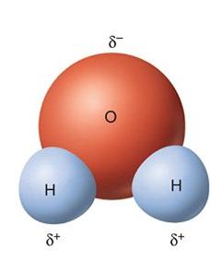A solution is a homogeneous mixture made from a solute dissolving in a solvent.
* When a solid dissolves, the particles that make up the solid break away from the solid lattice and mix with the solvent molecules.
* The formation of a solution involves the rearrangement of bonds:
* The bonds between the particles in the solid (solute) are broken.
* The bonds between the liquid particles are disrupted as the solute particles move in between them.
* New bonds are formed between the solute particles and the liquid particles.
* The relative strengths of the bonds that need to be broken and the new ones formed is a major factor in determining whether a solution forms.
* If the bonds being broken are of similar strength or weaker than the new bonds being formed, then the solute should dissolve in the solvent.
* A rule of thumb used to predict solubilities is ‘like dissolves like’, e.g. a polar solvent should dissolve a polar solute.
* A solute with hydrogen bonds between the molecules should dissolve in water because the new bonds formed between the solute and water are also hydrogen bonds.
* A solute with only dispersion forces between its molecules (i.e. a non-polar solute) will not dissolve in water because hydrogen bonds need to be broken between the solvent (water) molecules, but only dispersion forces can form between the solute and solvent molecules.
* A non-polar solute will dissolve in a non-polar solvent because the bonds broken (between the solute and between the solvent molecules) are dispersion forces and the new bonds formed between the solute and solvent are also dispersion forces.
* For polar organic molecules such as alcohols:
* the solubility in water decreases as the hydrocarbon chain increases in length
* the solubility in a non-polar solvent decreases as the number of polar functional groups on the hydrocarbon chain increases.
* The solubility of a polar solute, and an ionic compound, decreases as the polarity of the solvent decreases.
* The solubility of a non-polar solute increases as the polarity of the solvent decreases.
* When ionic solids dissolve in water, the polar water molecules are attracted to the positive and negative ions. Ion–dipole forces hold the molecules to the ions.
* Precipitates form because the bonds that usually form between water and the ion instead occur between one ions and the other meaning that a new substance is formed if this substance is insoluble in water then it becomes a solid and remains a solid without creating new solution
* The ions with water molecules attracted to them are called complex ions. [Cu(H2O)6]2+ is an example of a complex ion.
* One mole is the amount of substance that contains 6.022 × 1023 particles of that substance.
* 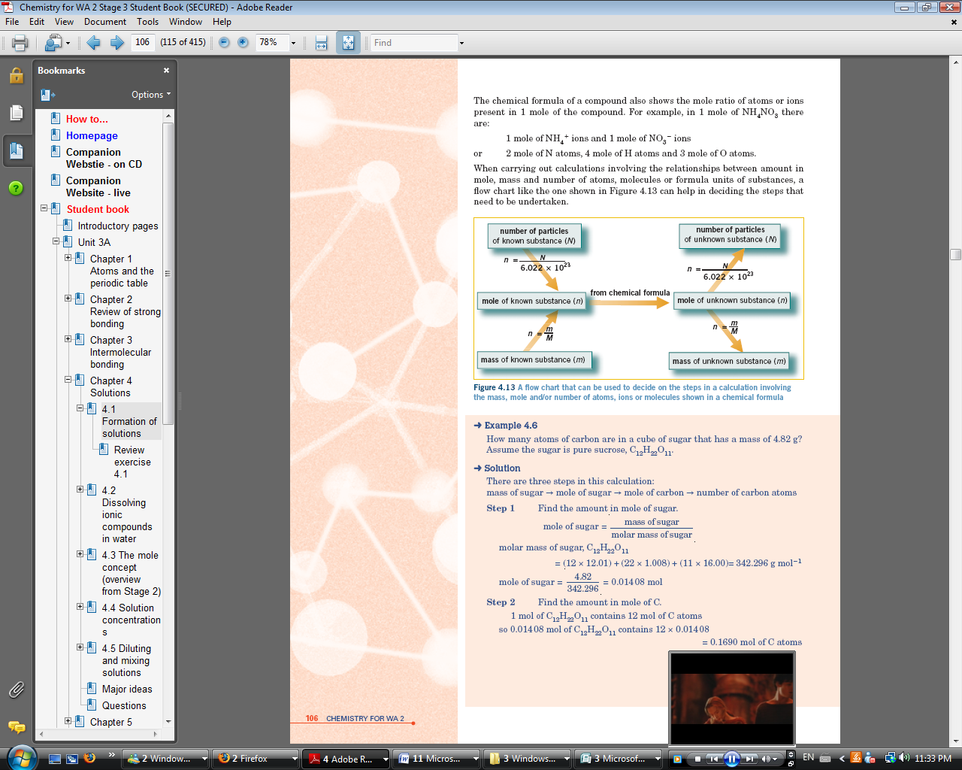One mole of any substance has a mass equal to its relative atomic, molecular or formula mass expressed in grams.
* The relative atomic mass (or atomic weight) of an atom is the mass of that atom compared to the mass of a C-12 atom that is assigned a mass of 12 exactly.
* The chemical formula of a compound shows the mole ratio of atoms or ions present in 1 mole of the compound.
* A flow chart showing the relationships between amount in mole, mass and number of atoms, molecules or formula units of substances.
* The concentration of a solution refers to the quantity of solute dissolved in a particular quantity of solution.

**Important Formulas**

$n=\frac{m}{M}$

*Avogadro’s number= $6.022×{10}^{23}$*

$n=\frac{number of particles (N)}{6.022×{10}^{23}}$*Formula or Molecular Mass= All Molar masses added up*

The Concentration of a liquid*= $C=\frac{n}{V}units {mol L}^{-1}$* For the mass of grams of solute $C=\frac{m}{v} units {gL}^{-1}$

**Avogadro’s number: $6.022×{10}^{23}$**  describes the number of atoms or molecules in a mole of a substance.

**Percentage composition by mass: Percentage composition by volume:**

$\%\frac{W(mass)}{W(mass)}=\frac{mass of solute in grams}{mass of solution in grams}×100$ $\%\frac{V(volume)}{V(volume)}=\frac{volume of solute in mL}{volume of solution in mL}×100$

**Percentage composition mass/volume: Concentration in ppm:**

$\%\frac{W(mass)}{V (volume)}=\frac{mass of solute in grams}{volume of solution in mL}×100$ $ppm=\frac{mg of solute}{kg or L of solvent}$

* When more solvent is added to a solution, the concentration of the solution decreases. Providing no solution is lost from the container:
* mole of solute in concentrated solution =mole of solute in dilute solution and
* 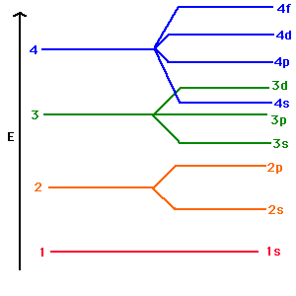concentration of initial solution × initial volume = concentration of final solution × final volume or *c1V1=c2V2*

**ATOMS AND THE PERIODIC TABLE**

**Atoms**

* Atoms are composed of protons, neutrons and electrons. A proton has a +1 charge, an electron a –1 charge and a neutron is neutral.
  + In an electrically neutral atom, the number of protons equals the number of electrons.
  + The atomic number, *Z*, of an element is the number of protons in the nucleus of an atom of that element.
  + The mass number, *A*, of an atom of an element is the sum of the number of protons and neutrons in the nucleus of that atom.
  + 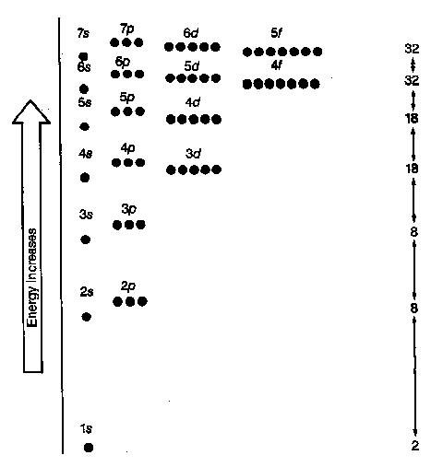The structure of an atom can be represented as where X is the element’s symbol.
  + Isotopes are atoms of the same element that have different numbers of neutrons in the nucleus.
* Ions are charged atoms. Positive ions have more protons than electrons, and negative ions have more electrons than protons.
  + The electrons in an atom can exist only in certain allowed energy levels or shells.
  + Electron configurations can be written showing the number of electrons in each shell; for example, an atom with 20 electrons has a configuration of 2, 8, 8, 2.
  + Valence electrons are electrons in the outermost shell of an atom.

**The Periodic Table**

* + In the periodic table, the elements are arranged in order of increasing atomic number.
  + Periods are horizontal rows of elements in the periodic table.
  + Groups are vertical columns of elements in the periodic table. Elements in the same group in the periodic table have the same outer-shell electron arrangement and they share some similar properties.
  + The behaviour of substances within and around us can be predicted and understood from knowledge of the periodic table.

**Ionisation Energy and Electronegativity**

* + Trends in 1st ionisation energy

1. The atoms nuclear charge
   * Depends upon its # of protons
   * Increasing nuclear charge means electrons are attracted more strongly tot eh nucleus and so ionisation energy increases with increasing nuclear charge
2. The distance between the nucleus and outermost electron – ATOMIC RADIUS

* As the atomic radius increases so the strength of attraction between the nucleus (+) and the outer electron (-) decreases
* Thus ionisation energy decreases with increasing atomic radius

1. Shielding by inner electrons

* Each electron in the atoms electron cloud repels each other electron
* The more electrons there are between the outer electrons and the nucleus the more easily the electron is removed and the lower the ionisation energy
  + Successive ionisation energies increase for an atom: – gradually as the charge on the ion being formed increases – markedly when the electron is removed from a shell closer to the nucleus.
  + Core charge is determined by subtracting the number of inner-shell electrons from the number of protons in the nucleus.
  + 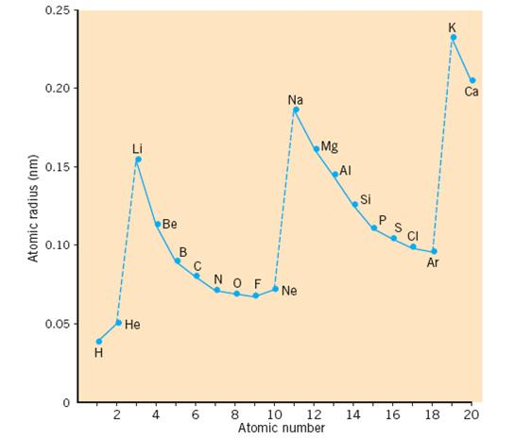The atomic radius, ionisation energy and electronegativity of an element depend on the core charge experienced by the outermost electrons and the average distance of these outermost electrons from the nucleus.

**Atomic Radius**

* The atomic radius of a chemical elements is a measure of the size of its atoms usually the mean or typical distance from the nucleus to the boundary of the surrounding cloud of electrons
  + Atomic radius increases down a group and decreases across a period.
  + The decrease in atomic radius that occurs for elements further to the right of the period might be unexpected but is primarily due to the atom’s increasing nuclear charge. Higher nuclear charge increases the attraction of electrons bringing them closer to nucleus thus resulting in a decreased atomic radius.
  + The increase in atomic radius down a group is due to the higher shell number of the outer electrons for elements lower in a group. At the start of each period electrons commence filling higher shells. Electrons in higher shells are generally further away from the nucleus and this causes the atoms further down a group to have a larger radius.
  + The atomic radius of a metal is defined as being half the distance between the centres of two adjacent atoms in the metallic lattice i.e. 1/2 d.
  + For non metal atoms that form diatomic molecules atomic radius is half the distance between the centres of two bonded atoms i.e. 1/2/ d.

**Ionisation Energy**

* + Ionisation energy is the energy required to remove the most loosely bound electron from an atom, in the gaseous phase.
  + Measures the minimum amount of energy needed to remove the single most loosely bound electron from an atom in the neutral gaseous state
  + 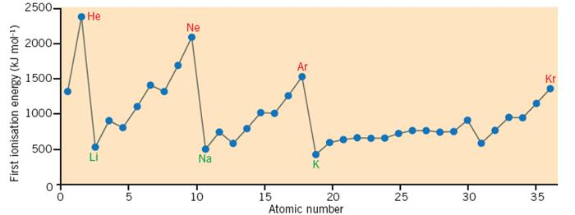First ionisation energy decreases down a group and increases across a period.

**Electronegativity**

* + The ability of an atom in a molecule to attract electrons to itself
  + 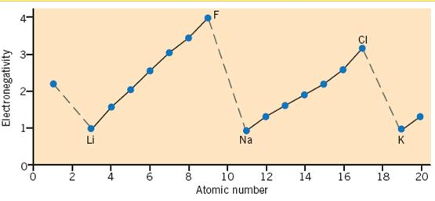Generally non-metal elements have the highest values of electronegativity. This is to be expected as these elements typically gain electrons to form negative ions
  + Conversely metals have low electronegativity. Within the periodic table there is a general trend of increasing electronegativtiy from left to right in any period. Down any group the electronegativities show a gradual decrease,
  + Electronegativity is a measure of the electron-attracting power of an atom in a molecule.
  + Electronegativity decreases down a group and increases across a period.

**BONDING**

**IONIC COMPOUND –**

A compound made of both metallic and non-metallic atoms

* Ionic compounds have characteristic physical properties as listed in the table below.
* Ionic substances consist of positive ions and negative ions arranged in a regular lattice.
* Ionic bonding is the electrostatic attraction between oppositely charged ions.
* The ionic bonding model can be used to explain the properties of ionic crystals as shown in Table 3.8.

|  |  |
| --- | --- |
| **Property** | **Explanation** |
| high melting and boiling points, hardness | strong attractive forces between the positive and negative ions |
| brittleness | when a layer of ions moves, repulsion between ions of similar charge occurs and the crystal shatters |
| non-conductor of electricity in solid state | positive and negative ions are held by strong ionic bonds in a lattice |
| conductor in molten state and aqueous solution | positive and negative ions are no longer arranged in a rigid lattice, they are relatively free to move |

* Ionic bonding is the electrostatic attraction between positive ions and negative ions in a crystal lattice.
* In the formation of ionic compounds, metals, with lower ionisation energies, form positive ions or cations, and non-metals form negative ions or anions.
* Ions can include the monatomic metal and non-metal ions as well as a range of polyatomic ions in which individual atoms are covalently bonded, but overall there is an ionic charge.
* The properties of ionic compounds such as high melting and boiling points, non-conductivity in the solid state, but conductivity when molten or dissolved in water, and brittleness can be explained in terms of the arrangement of ions in the solid crystal lattice.
* Positive ions are named after the element from which they were derived, for example, Fe2+is the iron(II) ion.
* Negative ion names usually end in ‘ide’; or, if oxygen is present, ‘ite’ or ‘ate’.
* When writing the formula of an ionic compound the following must be remembered:
  + the formula of the positive ion is written before the formula of the negative ion. The charges of the ions are not shown in the formula.
  + the total positive charge must equal the total negative charge. In the formula, subscripts are used to indicate the relative numbers of ions required for neutrality.
  + when there are two or more units of a polyatomic ion in a formula the polyatomic ion formula is enclosed in brackets.
* When writing the name of an ionic compound, the name of the positive ion is given first, followed by the name of the negative ion.
* Ions can be formed by the transfer of electrons from atoms of a metal element to atoms of a non-metal element.
* Electron dot diagrams can be used to show the arrangement of valence electrons in atoms, ions and ionic compounds. Square brackets are usually drawn around the electron dot diagram of an ion.

**COVALENT MOLECULAR COMPOUND** –

A compound made up of non-metallic atoms only

* Within molecules, atoms are held together by the electrostatic attraction between shared electrons and the nuclei of atoms. This form of bonding is called covalent bonding.
* When atoms combine to form molecules they often share electrons so that their outer shell has eight electrons or a noble gas electron configuration.
* In covalent molecular substances, the covalent bonds within the molecule are strong, but the bonding between the molecules is weak.
* Electron dot diagrams can be drawn to show the formation of a molecule and to represent molecules.
* A single covalent bond is formed when two atoms share a pair of valence electrons.
* A double covalent bond is formed when two atoms share two pairs of valence electrons. A triple covalent bond is formed when two atoms share three pairs of valence electrons.
* The electron pairs forming covalent bonds in molecules are called bonding electron pairs. The remaining valence electron pairs, if any, are called non-bonding electron pairs or lone pairs.
* In covalent molecular substances, the atoms in the molecules are held together by covalent bonds. (Covalent bonds are strong bonds.) But between the molecules there are weak attractive forces, sometimes called intermolecular forces or van der Waals forces.
* The properties of covalent molecular substances are listed and explained in the table below

|  |  |
| --- | --- |
| **Property** | **Explanation** |
| low melting and boiling points | forces between molecules are weak |
| non-conductors of electricity when solid or liquid | the molecules are uncharged and electrons are localised in covalent bonds or in the atoms |
| the solids are generally soft | forces between molecules are weak |

* Covalent bonding results from the electrostatic attraction between atomic nuclei and shared electrons occupying the region of space between these nuclei.
  + - Single, double and triple covalent bonds can form.
    - Electron dot diagrams, in which only the valence electrons around the atoms are shown, can be drawn for molecules and ions.
    - Covalent bonding is present in molecular substances as well as in covalent network substances.
* When naming covalent molecular compounds, the prefixes ‘mono-’, ‘di-’, ‘tri-’, ‘tetra-’, ‘penta-’ and ‘hexa’ are often used to indicate how many of each type of atom are in a molecule of the compound. If there is only one of the first element in the compound you don't need to use mono
* Compounds comprising polyatomic ions, contain both ionic and covalent bonds.

**COVALENT NETWORK COMPOUND** – Carbon(diamond,graphite), Boron , Silicon, Silicon Carbide, Silicon Dioxide

A compound made up of Silicon and Oxygen or Carbon and Silicon*

*Carbon is the only element that can form a covalent network substance by itself e.g. graphite and diamond

* In covalent network substances, every atom is covalently bonded to other atoms, forming a giant network lattice. No separate molecules can be distinguished.
  + - In covalent network substances, the strong covalent bonding extends throughout the lattice.
    - Covalent network substances have much higher melting and boiling points, and are usually much harder than covalent molecular substances.
* The properties of covalent network substances are listed and explained in the table below

|  |  |
| --- | --- |
| **Property** | **Explanation** |
| very high melting and boiling points | strong covalent bonding extending throughout the lattice |
| non-conductors of electricity in the solid and liquid states | electrons localised (except in graphite) in covalent bonds |
| hard and brittle | atoms strongly bonded, distortion breaks covalent bonds |

**METALLIC COMPOUND** - A compound made up of metals only

* The characteristic physical properties of metals include:
  + good conductors of electricity and heat in both the solid and liquid states
  + shiny when freshly cut or cleaned
  + malleable and ductile
  + many are hard, tough and relatively dense solids with high tensile strength
  + silver in colour, except gold and copper
  + melting points vary over a wide range but most are reasonably high
  + sonorous.
  + These type of properties are typical of elements with low ionisation energy.
  + Metallic bonding involves the electrostatic attraction of positive metal ions for delocalised valence electrons.
    - Metallic bonding explains properties such as conductivity of heat and electricity, malleability and ductility, lustre and melting points.
    - As the charge on the positive ions in the metallic lattice increases, so does the attraction between those ions and the delocalised electrons.
    - As the atomic radii of the metal atoms increase down a group, the attraction of the positive ions for the delocalised electrons decreases.
    - When metals lose electrons in chemical reactions, they behave as reductant.
* A metal consists of a lattice of positive ions surrounded by a ‘sea’ of mobile delocalised valence electrons.
* Metallic bonding is the electrostatic attraction between the delocalised electrons and the positive ions in the metallic lattice.
* An alloy is a homogenous mixture formed when one or more elements are added to a metal.
* The metallic bonding model can be used to explain the properties of metals as shown in the table below

|  |  |
| --- | --- |
| **Property** | **Explanation** |
| Relatively high density | positive ions tightly packed in the lattice |
| Malleability and ductility | layers of positive ions can slip over one another without disrupting the metallic bonding; metallic bonding is non-directional |
| Conductivity of electricity and heat | mobile, delocalised electrons transfer charge and heat energy |
| High melting and boiling points | strong metallic bonding exists throughout the entire lattice |

**OVERVIEW OF BONDING**

* The structure, bonding and properties of the four classes of substances are summarised in the table below

|  |  |  |  |  |
| --- | --- | --- | --- | --- |
|  | **Metallic** | **Ionic** | **Covalent molecular** | **Covalent network** |
| **Examples** | Cu, Al, Zn, Ca, Na | NaCl, CaCO3, MgO,  CuSO4 | NH3, H2O, HCl, SO2, Ne, Cl2, CCl4, C2H5OH | diamond, Si, SiC, SiO2, graphite |
| **1 Types of elements forming the substance** | metal elements | formed between metal and non-metal elements | formed between  non-metal elements | most are formed by  non-metal elements of group 14 |
| **2 Structure**  **a** Constituent particles | positive ions and  delocalised electrons | positive and negative ions | neutral molecules | atoms |
| **b** Arrangement of  particles in solid | lattice of positive  ions, sea of  delocalised electrons around ions | lattice of positive and negative ions | molecules organised in a lattice, each molecule composed of atoms bonded together | atoms organised in a  lattice |
| **3 Bonding**  **a** Principal attractive forces between particles | electrostatic  attraction between  delocalised electrons  and positive metal  ions, called metallic  bonding | electrostatic attraction between positive and negative ions, called ionic  bonding | **i )**within molecules,  electrostatic attraction between shared electrons and nuclei, called covalent bonding  **ii )** weak bonds  (intermolecular forces) between molecules | electrostatic attraction between shared electrons and nuclei, called covalent bonding |
| **b** Strength of bonds | strong | strong | covalent bonds are strong, intermolecular forces are weak | **st**rong |
| **4 Properties**  **a** Melting and boiling points | most are high | high | low | Very high |
| **b** Electrical conductivity | good conductors  in solid and liquid  states | non-conductors in solid state, good conductors in liquid state and in aqueous solution | non-conductors in solid and liquid states | non-conductors in solid and liquid states (except graphite) |
| **c** Hardness and  malleability | most are hard,  malleable and ductile | hard and brittle | most are soft | Very hard and brittle |

**SECONDARY OR INTERMOLECULAR FORCES AND BONDS**

* + - Primary bonds found in substances include metallic, ionic and covalent. These are strong and dominant bonds which dictate the substances physical properties
    - Secondary bonds are waker forces of attraction that are found in molecular substances
    - They are referred to as intermolecular forces or Van der Waals forces
    - There are no strong electrostatic forces between molecules
    - They are very weak
    - In some substances they make significant contributions in determining the substances physical properties
    - Gases condense and liquids freeze due to mutual forces of attraction between molecules
    - 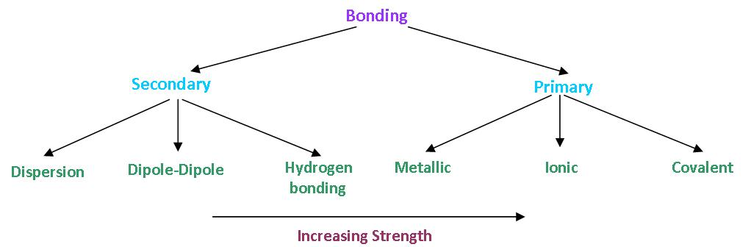Intermolecular forces between small molecules are weak compared with intra molecular forces that bond atoms within molecules
    - The various types of intermolecular forces of attraction are collectively called van der Waals forces.

Intermolecular forces include dispersion forces, dipole– dipole forces and hydrogen bonds.

* + - Molecular shape can be predicted using the valence shell electron pair repulsion hypothesis, which states that the valence electron pairs in an atom repel one another and are positioned as far apart as possible.
    - Both bonding pairs and non-bonding pairs of electrons exert this repulsive force.
    - Multiple bonds are regarded as a single area of negative charge when using the valence shell electron pair repulsion hypothesis.
    - Non-bonding electron pairs and multiple bonds exert a slightly greater repulsive force than bonding electron pairs.

**Polar bonds**

* + - A polar covalent bond is one in which there is a difference in the electronegativity of the atoms involved in the bond, causing the electrons to be attracted closer to the more electronegative atom.
* A bond formed between two atoms which differ greatly in electronegativity will be *ionic* because of the strong tendency for an electron to be transferred completely form the metallic element to the non-metallic element.
* When a bond is formed between two identical atoms, the electrons are shared equally and the bond is purely covalent
* When two different types of atoms form a covalent bond, the electrons as not shared equally between the atoms. The electron pair would spend more time in the vicinity of the more electronegative atom which will acquire a partial negative charge
  + - For a molecule to be polar, it must have at least one polar covalent bond and be asymmetrical. Such a molecule will be a dipole because the centres of positive and negative charges are at different points in the molecule.
* Covalent bonds in which there is an uneven charge distribution are called POLAR BONDS – they form what is known as a bond dipole (electric dipole.
  + - An alternative strategy for determining the polarity of a molecule with more than one polar bond is to undertake a vector addition of the individual bond dipoles.
* A dipole is represented as an arrow (=>), this represents the negative end of the dipole

|  |  |  |  |
| --- | --- | --- | --- |
| **Molecule** | **Difference in Electronegativity** | **Result** | **Bond** |
| F-F | 0 | Equal sharing | Non-polar |
| O-F in F2O | 0.52 | F more electronegative | Polar bond |
| N-F in NF3 | 0.92 | F more electronegative | Polar bond |
| C-F in CF4 | 1.41 | Large difference | Strong polar bond |
| B-F in BF3 | 1.92 | Large difference | Very polar bond |
| BeF in BeF2 | 2.39 | Very large difference | Very polar bond |
| Li-F | 3.0 | Charge separation | Ionic bond |

**Molecular Dipoles**

* A nett dipole in one direction is formed only when the molecule is not symmetrical
* A molecular nett dipole is the vector sum of all the bond dipoles within a molecule. Examples include water, ammonia and hydrogen sulphide
* A non symmetrical molecule with polar bonds will have a nett molecular dipole. In symmetrical molecules the nett dipole is zero
* Covalent molecular polar substances are formed when there is an uneven charge distribution within the molecule
* To determine which molecule have a nett charge separation we needs to consider the presence of polar bonds and the shape of the molecule

**Dispersion Forces**

* Dispersion forces exist between all molecules, atoms and ions and result from the attraction between instantaneous or induced dipoles.
* Dispersion forces are the only intermolecular forces between non-polar molecules and atoms of noble gases.
* Dispersion forces increase in strength with increasing number of electrons.
* Dispersion forces are also influenced by molecular shape—the greater the 'fl at' surface area of the molecule, the stronger the dispersion force.
* They occur in all molecular materials
* Dispersion forces are formed when the electrons in a molecule or atom, by the nature of random motion, are found on the same side of a molecule or atom
* This causes the formation of a *temporary dipole* that interacts with other molecules or atoms in a similar situation.
* A temporary polar molecule can cause nearby molecules to develop similar dipoles called induced dipoles
* Molecules with temporary dipoles or induced dipoles experience weal electrostatic forces
* The temporary dipoles and induced are in a state of constant rapid change (approx. 10-12 sec) as dipoles form and decay
* They are present between all molecules but they are the only forces of attraction between –

1. the noble gases (atoms)
2. neutral molecules like halogens and alkanes (non-polar)

* These are extremely weak. The weakness of these forces is indicated by the low melting and boiling points of the substances that exhibit these forces exclusively.
* Substances whose molecules attract by dispersion forces only, will be soluble in each other
* Examples include
  + Diatomic gases
  + Noble gases
  + Discrete covalent molecules
  + Many polymers
  + The dispersion forces depend on –
    - The number of electrons (and protons). As this increases in a series of related substances (e.g. noble gases, alkanes) so does the force of attraction between particles e.g. increasing boiling point down halogens and noble gas groups
    - The shape of the molecules also affects dispersion forces. Linear long molecules have greater surface area∴ increase attraction – compact=less attraction
    - Greater surface to surface contact (more points of attraction) between molecules of pentane in liquid phase produces stronger forces of attraction. The more symmetrical molecules pack closer together in the solid phase
    - As the size of the molecules increases so does the strength of the dispersion forces, This is dues to greater surface contact between molecules.

**Dipole-Dipole Interactions**

* + - Dipole–dipole forces are present between molecules that are polar.
    - Very weak forces that occur between polar molecules
    - Dipole-dipole interactions are the result of the interaction of the dipoles on the individual molecules on a polar substance i.e. Polar molecules experience a weak electrostatic attraction between the dipoles on neighbouring molecules
    - Relatively weak forces but stronger than dispersion forces
    - Strength of these forces increases with increasing molecular polarity
    - 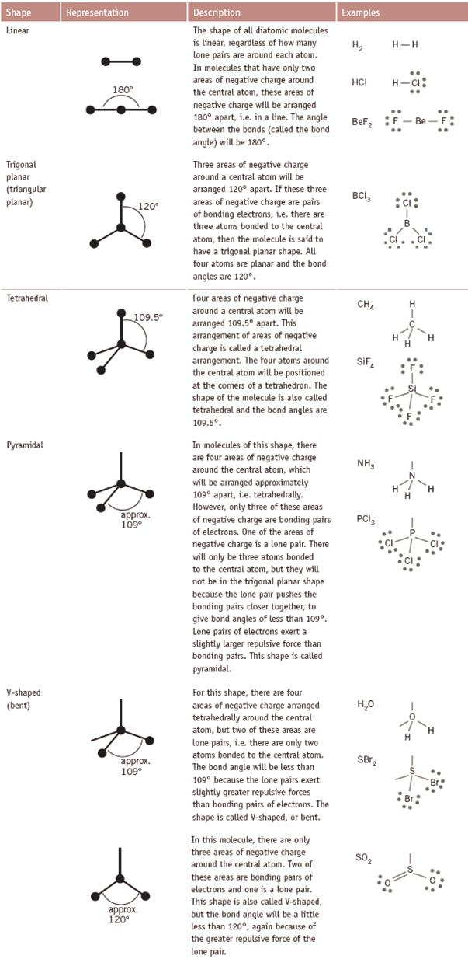These forces hold the molecules together and affect many physical properties; the degree of the effect depends on the size of the dipole
    - These properties include:

1. Melting point – increases as dipole gets stronger
2. Boiling point – increases as dipole gets stronger
3. Viscosity – increases as dipole gets stronger
4. Density – increases as dipole gets stronger
5. Solubility – polar dissolves polar, non polar dissolves non-polar
6. Heat of vaporisation – increases as dipole gets stronger.

**Hydrogen bonding**

* + - Hydrogen bonds are an extreme form of a dipole–dipole force.
    - Hydrogen bonding takes place between polar molecules containing an N–H, O–H or F–H bond and other polar molecules containing N, O or F.
    - Hydrogen bonds are about 10 times stronger than other van der Waals forces but about one-tenth of the strength of a covalent bond.
    - A special form of dipole-dipole attraction
    - Occurs when a hydrogen atom is covalently bound to either fluorine, oxygen and nitrogen
    - Example include H2O, NH3, HF
    - A hydrogen bond is an interaction between a lone pair of e- from an F, O or N atom and a hydrogen atom that is already covalently bonded to another F,O and N
    - These elements are very electronegative while hydrogen is not
    - This causes a strong dipole which creates electrostatic attraction between neighbouring molecules
    - These bonds are stronger than dispersion and dipole-dipole forces due to

1. High charge separation
2. Small size of the hydrogen atom; allows for close approach
3. Attraction between H nuclei (+) and unshared electron pair of F,O or N

* Substances which experience H bonding between their molecules are extremely soluble in other substance which can also H bond
* In substances such as HF, NH3 and H2O the BP and MP are elevated due to the hydrogen bonds holding the substance together
* This is most noticeable in water due to an effective double hydrogen bond
* Note: the presence of hydrogen bonding in ice creates a very open structure which causes the density of ice to be less than that of water
* Intra molecular hydrogen bonding can also exist e.g. isomers
* Hydrogen bonds affect the physical properties as for dipole-dipole interactions but to a greater extent due to their greater strength

Dispersion Forces < Dipole-dipole forces<hydrogen bonds< covalent bonds

**Shapes**

* + - To determine the shape of a molecule

1. Draw e- dot diagram
2. Count number of e- pairs
3. Determine which shape
4. Consider number of bonding pairs to determine actual shape
   * + Shapes can be: linear, trigonal planar (special cases), tetrahedral, pyramidal, v-shaped/bent.
     + The shapes of simple molecules are listed in the table below

|  |  |  |  |
| --- | --- | --- | --- |
| **Number of areas of negative charge around central atom** | **Number of lone pairs of electrons around central atom** | **Electron pair arrangement**  **around central atom** | **Shape of molecule** |
| 1 | 0 | Linear | Linear |
| 2 | 0 | Linear | Linear |
| 3 | 0 | Trigonal planar | Trigonal planar |
| 4 | 0 | Tetrahedral | Tetrahedral |
| 4 | 1 | Tetrahedral | Pyramidal |
| 4 | 2 | Tetrahedral | V-shaped or bent |
| 4 | 3  **Density**  ρ= $\frac{m(ass)}{v(olume)}$ In water 1mL=1g $$n=\frac{V}{22.41}$$ *V=Volume* | Tetrahedral | Linear |

**Important Formulas**

$$n\left(unknown\right)=\frac{nc(known)}{nc(unknown)}×moles of known$$

$n=\frac{m}{M}$

$m=nM$

n.c.= mole coefficient

*m=mass*

*n= moles*

*M=Molar mass*

*Avogadro’s number= $6.022×{10}^{23}$*

$n=\frac{number of particles (N)}{6.022×{10}^{23}}$*Formula or Molecular Mass= All Molar masses added up*

**MOLE:** the molecular weight of a substance expressed in grams

**Avogadro’s number: $6.022×{10}^{23}$**  describes the number of atoms or molecules in a mole of a substance.

**THE MOLE (will eat you☺)**

* **Relative molecular or formula mass (Mr)** - the mass of a molecule or formula unit of that substance compared with ${\frac{1}{12}}^{th}$ the mass of an atom of carbon-12. It is found by adding up all the relevant relative atomic masses of the elements in a molecule
* A **mole** of any substance is the amount of substance that contains $6.022×{10}^{23}$ (the Avogadro constant) atoms, molecules or formula units of that substance.
* One mole of any substance has a mass equal to its relative atomic, molecular or formula mass expressed in grams. This is the **molar mass (M)** of the substance measured in gmol-1.
* The relationship between the amount in mole (n) of a substance and the number of atoms, molecules or formula units (N) of the substance is:
 $$n=\frac{N}{6.02×{10}^{23}}$$

 + The relationship between the amount in mole (n), mass (m) and molar mass (M) of any substance is:
$$n=\frac{m}{M}$$

* The percentage composition of a chemical compound specifies the percentage, by mass, of each of the different elements in the compound. Two formulas for percentage composition are given below. The first formula is for the percentage composition from a compound’s formula. The second formula is for the percentage composition from experimental data:

$$ppm=\frac{mg of solute}{kg or L of solvent}$$

ppm=parts per million

$$\% element in compound= \frac{mass of element in 1 mole of compound ×100}{total mass of 1 mole of compound}$$

$$\% element in compound= \frac{mass of element in sample ×100}{total mass of sample}$$

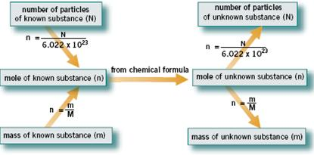

* **D**ifferent calculations involving chemical formulas are possible as summarised to the right=>
* Precipitation reactions occur when two or more solutions are mixed and an insoluble solid is formed.
* A table of solubilities can be used to predict whether a precipitation reaction is likely to take place.
* Ionic equations, showing the ions that react to form the insoluble substance, are written for precipitation reactions.
* Kelvin temperature (K) = Celsius temperature (°C) + 273.
* ***Avogadro’s hypothesis is that equal volumes of gases measured under the same conditions of temperature and pressure contain equal numbers of particles.***
* 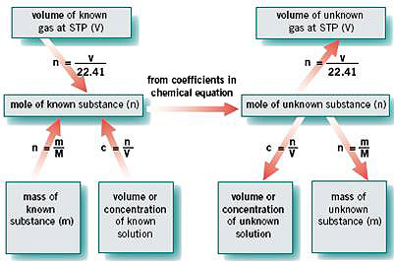The **molar volume of a gas** is the volume occupied by a mole of gas. For an ideal gas at STP (273 K [0°C] and 101.3 kPa), this is 22.41 L. $n=\frac{V}{22.41}$
* The balancing coefficients in a balanced equation show the mole ratio of the substances involved in the reaction.
* The mole is the unifying concept that enables the calculation of masses of substances, volumes and concentrations of solutions, and volumes of gases at STP involved in reactions (see Figure 9.13 to the right)=>
* **Gay-Lussac’s law** states that the volumes of different gases involved in a reaction, if measured at the same temperature and pressure, are in the same ratio as the coefficients in the balanced equation.

**New Concepts**

* + Chemical reactions are processes in which chemical changes occur and they are characterised by the formation of new substances.
  + A chemical reaction can be represented by a balanced chemical equation.
  + A chemical equation is said to be ‘balanced’ when the number of atoms of each element on each side of the equation are the same, and when the total charge on each side of the equation is the same.
  + In an ionic equation, only the actual species consumed and produced in the reaction are shown.
  + 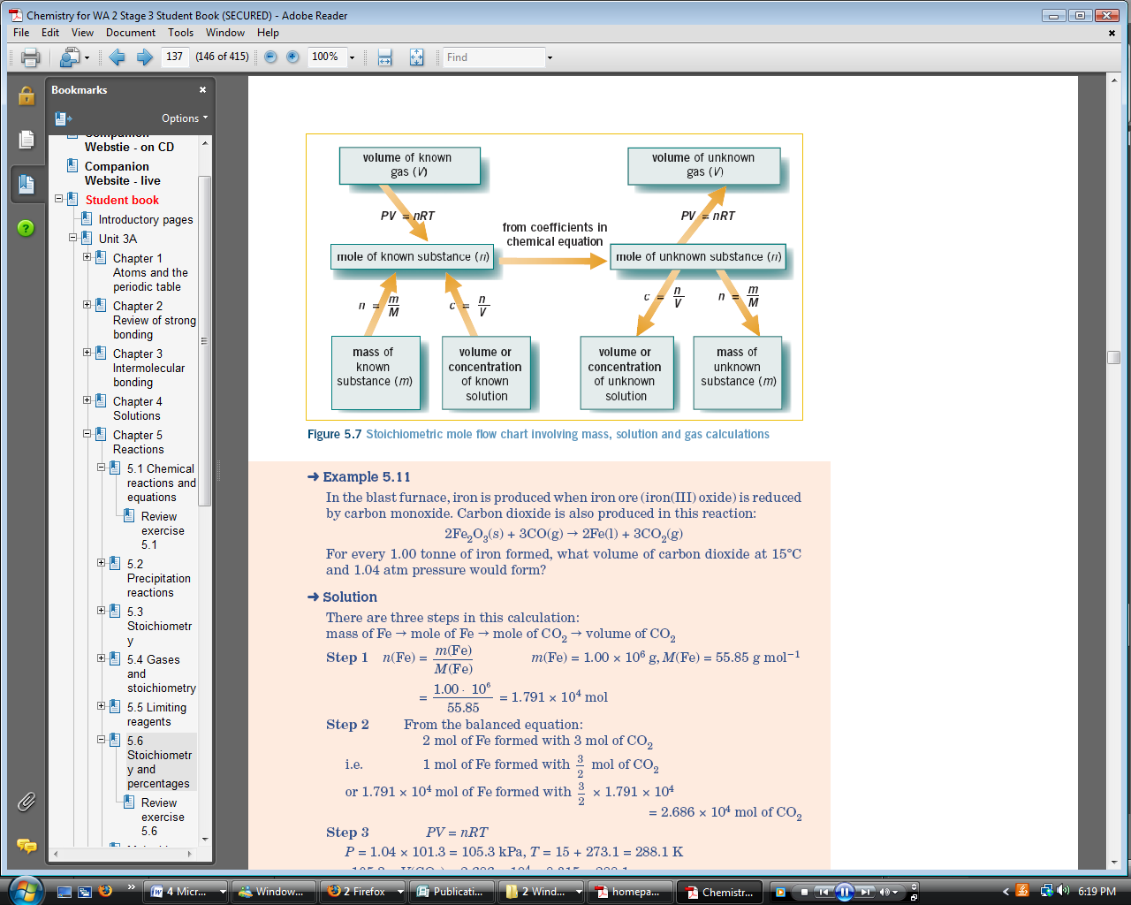A precipitation reaction is one in which two solutions are mixed and an insoluble substance (the precipitate) forms.
  + The solubilities of substances can be predicted using a solubility table
  + When the solutions of two ionic compounds are mixed, a precipitate will form if two of the ions combine to form an insoluble substance.
  + A balanced chemical equation shows the relationships between the number of particles of reactants and products in a chemical reaction. It also shows the mole ratio (the stoichiometric ratio) in which the reactants will react and the products will form.
  + The steps involved in stoichiometric calculations involving masses and volumes and concentrations of solutions can be shown on a flow chart
  + Kelvin temperature = Celsius temperature + 273
  + The relationships between the volumes (*V*), pressures (*P*), temperatures (*T*) and amounts (*n*), in mol, of gases are shown in a variety of equations:

**Boyles Law:** For a *constant mass of gas at a constant temperature*, the volume is inversely proportional to its pressure. $V∝\frac{1}{P}$

Formula of Boyles Law: $P_{1}V_{1}=P_{2}V_{2}$

**Charles Law:** For a *constant mass of gas at a constant pressure*, the volume is directly proportional to its KELVIN temperature.

Formula of Charles’ Law: $\frac{V_{1}}{T_{1}}=\frac{V_{2}}{T_{2}}$

**Combined gas Law:** The two gas laws combined

Formula**: $\frac{P_{1}V_{1}}{T_{1}}=\frac{P_{2}V_{2}}{T_{2}}$**

Avogadro’s hypothesis: *V* α *n* where *V* is measured at constant temperature and pressure.

*PV* = *nRT*

where *P* is the pressure,

*V* is the volume,

*n* is the amount in mole,

*R* is a constant (the Universal gas constant) and

*T* is the Kelvin temperature.

* + The universal gas constant, *R*, has a value of 8.315 J mol-1 K-1, when *P* is measured in kPa, *V* in L and *T* in K.
  + Pressure conversions: 1 atmosphere = 760 mmHg = 101.3 kPa
  + Stoichiometric calculations can also involve gases, as shown in the flow chart.
  + According to Gay-Lussac’s law, the volume ratio of gases involved in a reaction is the same as the mole ratio given in the balanced equation.
  + When two reactants are mixed in ‘non-stoichiometric’ amounts, resulting in one of these reactants not being completely consumed in the reaction, the excess reagent is the reactant left over after the reaction and the limiting reagent is the reactant completely consumed.
  + The amount of limiting reagent is used to calculate the amount of product formed.

$$Percentage purity of a material= \frac{mass of pure substance}{mass of impure susbtance} ×100$$

$$Percentage yield of a reaction=\frac{actual yield}{theoretical yield}×100$$

**LIMITING REAGENT**

* + - Ionic equations are used for solution reactions to indicate more accurately the reaction taking place. Spectator ions are not included.
    - The limiting reagent in a chemical reaction is the substance that is completely consumed in the reaction. A reactant that is not consumed completely is said to be present in excess.
    - The flowchart given below can be used to map many of the steps in stoichiometric problems involving masses, volumes and concentrations of solutions and volumes of gases at STP.

Identifying the limiting reagent

There are two ways of finding the limiting reagent; one is shorter than the other.

*Question: Determine the limiting reagent when 9.87 moles of aluminium is added to 24.5 moles of hydrochloric acid*

2Al(s)+6HCl(aq) => 2AlCl3(aq) + 3H2(g)

Method 1:

1. Find Actual ratio between reactants
$$A.R.= \frac{n(HCl)}{n(Al)}=\frac{24.5}{9.87}=2.48$$

2. Find the stoichiometric ratio (ratio from equation) between reactants
$$A.R.= \frac{n(HCl)}{n(Al)}=\frac{6}{2}=3$$

3. If SR>AR then numerator is limiting reagent. If AR>SR then denominator is limiting reagent. .: HCl is the limiting reagent

Method 2:

1. Cross multiply the moles of each reagent by the stoichiometric ratio of the other i.e.

$$n\left(Al\right)×6=9.87 ×6=59.22$$

$$n\left(HCl\right)×2=24.5 ×2=49$$

By doing this we find HCl has the lower amount .: HCl is the limiting reagent

* 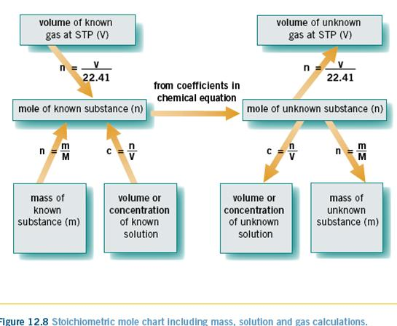If a calculation asks for the amount of a product formed in a limiting reagent question use the limiting reagent found to find the moles of product, do NOT use the other reactant.

**Reactions, equations and stoichiometry**

**Chemical change**

* During a chemical reaction substances known as reactants disappear over time to be replaced by chemically different substances known as products. When this happens the total mass (amount of material) and number of atoms present is unchanged but the way in which the various atoms are bonded does change
* A chemical change is summarised using a chemical equation. It shows the chemical formula of the reactants and products and has an arrow (=>) pointing towards the products. A plus sign separates each substance in the equation

**Balancing equations**

* In a balanced equation numbers called coefficients are written in front of each formula.
* A coefficient is the number by which the amount of atoms in a molecule has to be multiplied by to balance both sides of the equation
* To write a balanced equation the following steps should be followed
  1. Write the formulae of the reactants (separated by a + sign) followed by an arrow with the formulae of the products (also separated by a + sign) to the right of the arrow
  2. Place coefficients in front of formulae as needed so that there are equal numbers of each type of atom on either side of the equation. Priority is to first balance any atoms that appear in only one formula on each side of the equation
  3. Write subscripts (s), (l),(g) or (aq) to show the physical state of each substance

**EXAMPLE:** 2HCl(aq) + Mg(s) => MgCl2(aq)+ H2(g)

**Net ionic equations**

* Chemical reactions that happen in aqueous solution (where some substances are dissolved in water) are often better understood as a net ionic equation.
* In these equations any dissolved substances that mainly present as ions are shown as ions in the equation.
* Ions which are present in solution but do not take part in the chemical change are called spectator ions. These ions are not included in the net ionic equation.
* When writing a net ionic equation:
  1. Write a balanced equation (see above)
  2. Rewrite in ion form the formulae of any dissolved strong acids or dissolved ionic compound (substances with ionic bonds, i.e. a metal and a non metal). Do not change the formulae of any solids(s), liquids (l) or gases (g)
  3. Remove any spectator ions. To do this, reduce by an equal amount the number of any ion that appears unchanged on both sides of the equation until it is either gone from the equation or appears on only one side of the equation.

**EXAMPLE:** 2H+(aq) + Mg(s) => Mg2+(aq)+ H2(g)

**Sequential reactions**

* Ina series of sequential reactions, the product of an initial reaction goes on to become a reactant for a subsequent reaction.
* Many natural and industrial processes involve sequential reactions. The equations for several sequential reactions can be added to produce one overall equation.
* When adding a sequential reaction
  1. Identify the product in the first equation that becomes a reactant in the second equation. This is the linking reagent
  2. Multiply the coefficients of each equation by an appropriate factor so that the quantity if the linking reagent in step 1 is the same in both equations (i.e. coefficient)
  3. All the reactants form both equations are written as the reactants of a single equation. Similarly all the products of both equations added to the products side of the equation
  4. If a reagent appears on both sides of the equation it is reduced by an equal amount until it is either gone or appears on only one side of the equation

**REACTION RATE**

* + - 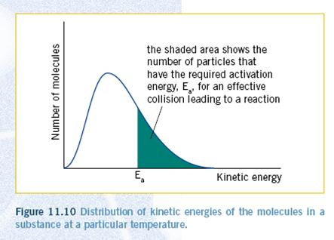Reaction rate is a measure of the change in some measurable amount of reactant or product as a function of time.
    - Rates can be measured from graphs of changes in some quantity against time, by determining the gradient of the graph at a particular time.
    - Collision theory establishes the three requirements for a chemical reaction—collisions, sufficient energy of collision (enough energy to overcome the activation energy barrier), and a favourable collision orientation.
    - Energy profile diagrams provide information about the activation energy and the heat of reaction for a chemical reaction.
    - The peak of the energy profile curve represents the activated complex or transition state.
    - At any temperature the particles in a substance have a range of kinetic energies.
    - Not all particles in a reaction mixture will have enough energy to overcome the activation energy barrier.
    - Chemical reactions are reversible and the back reaction also has activation energy.
    - Five factors that influence rate are—nature of reactants, concentration or pressure, temperature, state of subdivision and catalysts.
    - The effect of each of these factors can be explained in terms of collision theory.
    - 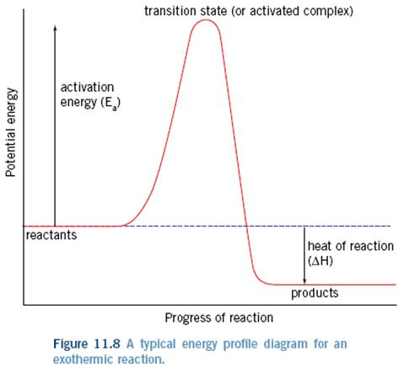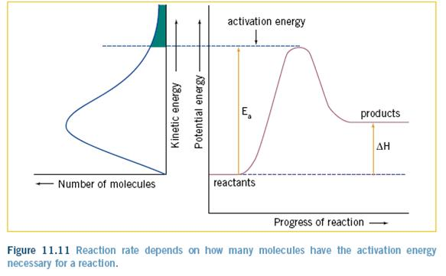Catalysts are substances that provide an alternative reaction pathway with lower activation energy and are not consumed in the reaction.

The diagram above on the left shows an endothermic reaction while the diagram on the right shows an exothermic reaction

The table below shows the how different factors affect the reaction rate

|  |  |  |
| --- | --- | --- |
| **Factor** | **Effect on reaction rate** | **Explanation** |
| **Concentration** | Raising the concentration of a reactant raises the reaction rate | A higher concentration of reacting particles causes an increase in the rate of collisions between these particles, hence an increase in the rate of reaction e.g., The rate of formation of hydrogen gas by the reaction of Zn(s) with HCl(aq) doubles if the concentration of HCl(aq) is doubled. This is due to the higher (doubled) rate of collisions between HCl(aq) [specifically H+(aq)] and Zn atoms on the zinc surface |
| **Pressure** | Raising the pressure of any reactant gas (by reducing volume or adding more of it) raises reaction rate | A higher pressure (by reducing volume or adding more gas) means a greater concentration of reacting gas molecules. This causes an increase in the rate of collisions between these molecules, hence an increase in rate of reaction e.g. in the Haber process where ammonia is formed from the reaction of H2(g) and N2(g) the reacting gases are kept at a pressure ≈350 times normal atmospheric pressure. This increases the rate of formation as the higher pressure means there is a greater rate of collision between H2(g) and N2(g) molecules. |
| **Temperature** | Increasing the temperature of the reaction mixture raises the reaction rate | At a higher temperature particles on average have a greater kinetic energy. This means a higher percentage of collisions have energy equal to or greater than the activation energy. Thus a greater percentage of collisions are successful and hence the reaction rate increases e.g., rate of food decay decreases if food is kept cool by refrigeration. This can be understood as at a lower temperature a lower percentage of collisions between molecules involved in the biochemical decay process has collision energy greater than or equal to the activation energy. Thus the rate of food spoilage decreases if food is kept cool. It is also true, that higher temperatures mean an increased rate of collisions between reacting particles. While this does contribute to an increased rate of reaction, its effect is known to be minor compared to the activation energy effect. |
| **Catalyst** | Adding a catalyst raises the reaction rate | A catalyst provides a reaction pathway with lower activation energy. As a result a greater percentage of collisions have energy equal to or greater than the activation energy, This more collisions are successful and hence the rate of reaction increases e.g. MnO2 (a catalyst) speeds up the decomposition of H2O2 (aq) into H2O (l) and O2 (g). This happened as the catalyst MnO2 provides a pathway of lower activation energy meaning a greater percentage of collisions involving H2O2 will have sufficient energy to form the products H2O(l) and O2(g). Catalysts can be consumed in the reaction, but then also come out the other side. |
| **State of subdivision** | Increasing the state of subdivision of solid or liquid reactant in a heterogeneous reaction (a reaction involving two different phases) will increases the rate of reaction | Heterogeneous reactions involve reactants that are in two different phases, e.g. solid/liquid, solid/gas or liquid/gas. In these reactions the reacting particles can only collide at the surface where the two phases make contact. Increasing the surface area exposes a greater amount of reacting particles to the possibility of a collision. This results in an increased rate of collision between reacting particles and hence the reaction rate increases e.g. Car engine fuel injectors spray liquid fuel into combustion chambers (cylinders) forming a fine mist of fuel (high surface area). This increases the rate of collision between is oxygen molecules (gas phase) and the fuel molecules (liquid phase), this increasing the rate of combustion |
| **Nature of reactants** | It is difficult to predict the effect of the nature of reactant on the reaction rate | The number of bonds which must be rearranged and the energy needed to achieve this are some of the variables affecting reaction rates for different reactions. The effect of this is difficult to predict e.g. The precipitate AgCl from the reaction between Ag+(aq) and Cl-(aq) is rapid under normal laboratory conditions yet the precipitation of MgC2O4 form the reaction of Mg2+(aq) and C2O4-(aq) is very slow. |

* + - The rate of a reaction can be determined by measuring the change in the amount of one of the reactants or one of the products of the reaction, in a given time interval.
    - Reaction rate = change in quantity of reactant (or product) in the time interval/time interval
    - The slope of a graph of quantity of reactant or product versus time at any particular time gives the reaction rate at that time.
    - According to the collision theory, for a reaction to occur:
  + the reactant particles must collide
  + the reacting particles must collide with sufficient energy to react, i.e with the required activation energy
  + on collision, the particles must have the correct orientation.
    - Activation energy is the minimum energy required by colliding particles for a reaction to occur.
    - The transition state, or activated complex, in a reaction:
  + is the highest potential energy state for the reacting system
  + corresponds to some stage in the reaction at which bond breaking and bond formation are taking place
  + is unstable, having no more than a temporary existence.
    - The potential energy of a reacting system changes during the reaction, as shown in Figures 6.2 and 6.3.
    - The activation energy of the forward reaction is the energy difference between the transition state and the reactants.
    - The change in enthalpy, ∆*H*, of a reaction is the difference in enthalpy (potential energy) between the products and the reactants.
    - For an exothermic reaction:
  + the products have less potential energy than the reactants
  + ∆*H* is negative (energy of products – energy of reactants)
  + the temperature of the surroundings increases.
    - For an endothermic reaction:
  + the products have more potential energy than the reactants
  + ∆*H* is positive
  + the temperature of the surroundings decreases.
    - Spontaneous reactions at room temperature tend to have small activation energies.
    - Factors that affect reaction rates are:
  + nature of the reactants—breaking covalent bonds requires more energy, therefore resulting in a slower rate than reactions just involving collision
  + concentration of the reactants
  + changing the concentration of a solution or partial pressure of a gas—alters the rate of collision of reacting particles
  + state of subdivision of the reactants—changing the surface area of the reactants alters the rate of collision of reacting particles
  + changing the temperature—alters the average kinetic energy of the particles, therefore changing the number of particles with the required activation energy to react
  + using a catalyst—catalysts are not permanently consumed in the reaction. They provide an alternative reaction pathway with a smaller activation energy than the activation energy for the uncatalysed reaction.
    - Not all reactions go to completion, because reactions are reversible.
    - When a chemical reaction system is at equilibrium:
  + the concentrations of the reactants and products present remain constant with time
  + the rates of the forward and reverse reactions are equal.
    - Dynamic equilibrium can also be established in physical systems, for example, equilibrium vapour pressure and saturated solutions.
    - The equilibrium law: for any reaction at equilibrium, for example, for the general reaction:

*a*A + *b*B ⇌ *c* C + *d* D

the fraction

$$k=\frac{{\left[C\right]}^{c}{\left[D\right]}^{d}}{{\left[A\right]}^{a}{\left[B\right]}^{b}}$$

has a constant value, the equilibrium constant (*K*), at a particular temperature. The equilibrium law expression does not include substances that are solids or pure liquids.

* + - An equilibrium constant:
  + is a constant value for a particular equation representing a reaction at a given temperature
  + changes in value if the temperature of a reaction is changed
  + indicates the extent of the reaction
  + provides no indication of the rate at which the equilibrium position is reached.
    - Le Châtelier’s principle states:

‘If a system at equilibrium is subjected to a change in conditions, the system will adjust to re-establish equilibrium in such a way as to partially counteract (oppose) the imposed change.’

* + - Equilibrium systems are put out of equilibrium when changes are made that increase or decrease the value of the equilibrium constant expression and alter the forward and/or reverse reaction rates by different degrees.
    - Equilibrium systems can be put out of equilibrium by various changes as shown below.

|  |  |
| --- | --- |
| **Change** | **Direction favoured to re-establish equilibrium** |
| Increase in concentration or partial pressure of a reactant or product | To decrease the concentration of that reactant or product |
| Decrease in concentration or partial pressure of a reactant or product | To increase the concentration of that reactant or product |
| Increase the volume of a gaseous system | To increase the number of gaseous particles |
| Decrease the volume of a gaseous system | To decrease the number of gaseous particles |
| Increase the temperature | To decrease the temperature by moving in the endothermic direction |
| Decrease the temperature | To increase the temperature by moving in the exothermic direction |
| Add a catalyst | No effect |

* + - When a change is made to an equilibrium system that puts it out of equilibrium, this imposed change is only partially counteracted in the re-establishment of equilibrium.
    - Catalysts do not change the position of equilibrium but they allow the system to reach equilibrium quicker.
    - When a change has been made, the effect on the rates at the new equilibrium position compared to the rates at the original equilibrium position are summarised below:

|  |  |
| --- | --- |
| **Change made to the system**  **at equilibrium** | **Forward and reverse reaction rates at new equilibrium**  **position compared to rates at original position** |
| Reactant or product added | Rates equal but increased |
| Reactant or product removed | Rates equal but decreased |
| Volume increased | Rates equal but decreased |
| Volume decreased | Rates equal but increased |
| Temperature increased | Rates equal but increased |
| Temperature decreased | Rates equal but decreased |
| Catalyst added | Rates equal but increased |

* + - In industrial chemical processes, the maximum yield of product for the minimum cost is sought. Factors affecting reaction rates, equilibrium and economics have to be considered in planning industrial processes and chemical plants. Because factors affecting reaction rates and equilibrium are sometimes in conflict, a compromise set of conditions may be needed in which a reasonable yield is obtained at a satisfactory rate and cost

**ACIDS AND BASES – REVIEW**

**Equations to know:**

ACID +METAL => Salt +H2(g) ACID + METAL SULFITE => SALT+ H2O(l)+SO2(g)

ACID + BASE => Salt + H2O(l) BASE+AMMONIUM SALT=> SALT+H2O(l)+NH3(g)

ACID + METAL HYDROXIDE => Salt + H2O (l) BASE+ NON METAL OXIDE=> SALT + H2O(l)

ACID + METAL CARBONATE => Salt + H2O+ CO2(g) ACID + METAL OXIDE => Salt + H2O(l)

ACID + METAL HYDROGENCARBONATE => Salt + H2O(l)+ CO2(g)

REACTIVE METAL + WATER => Metal Hydroxide + H2O(l) METAL + OXYGEN => Metal Oxide

METAL CARBONATE (heat) => Metal Oxide + CO2(g)

METAL HYDROGENCARBONATE (heat) => Metal Carbonate/ Metal Oxide + H2O(l)+ CO2(g)

* In general, a strong acid will have a weak conjugate base and a strong base will have a weak conjugate acid.
* Strong acids include hydrochloric acid, nitric acid and sulphuric acids; strong bases include the oxides and hydroxides of group 1 and 2 metals.
* Often the conjugate acid or base of a weak base or acid (respectively) is also weak.
* Acids that can donate more than one hydrogen ion (a proton) in an acid–base reaction are called polyprotic acids.

|  |  |
| --- | --- |
| **STRONG ACIDS** | |
| Hydrochloric Acid | HCl |
| Sulphuric Acid | H2SO4 |
| Nitric Acid | HNO3 |
| **WEAK ACIDS** | |
| Sulphurous Acid | H2SO3 |
| Phosphoric Acid | H3PO4 |
| Ethanoic Acid | CH3COOH |
| Carbonic Acid | H2CO3 |
| **STRONG BASES** | |
| Oxides of group 1 and 2 metals | Na2O, BaO |
| Hydroxides of group 1 and 2 metals | NaOH, Ba(OH)2 |
| **WEAK BASES** | |
| Metal Phosphates | Na3PO4 |
| Metal Carbonates | Na2CO3 |
| Ammonia | NH3 |
| Metal Hydrogen Carbonates | NaHCO3, KHCO3 |

**ARRHENIUS THEORY** of acids and bases:

* An acid is a substance that produces H+(aq) in solution.
* A base is a substance that produces OH-(aq) in solution.
* A neutralisation reaction is the reaction between an acid and a base.
* According to the Arrhenius theory, acids are substances that produce H+when dissolved in water and bases are substances that produce OH-when dissolved in water.

**BRØNSTED–LOWRY THEORY** of acids and bases:

* An acid is a proton (H+) donor.
* A base is a proton (H+) acceptor.
* Amphoteric substances can react as acids or bases.
* Every acid has a conjugate base which is related in the following way:

$HX↔H^{+}+X^{-}$ where HX is the acid and X- is its conjugate base

* Water is a weak electrolyte that ionises to form H+(aq) and OH-(aq) to a small extent.
* In the Brønsted–Lowry theory an acid is a substance that donates H_ (proton) and a base is a substance that accepts H_.
* A conjugate acid–base pair is any pair of substances that differ by one hydrogen ion.
* Strong acids (for example, HCl, H2SO4) and strong bases(for example, NaOH) are essentially completely ionised(acids) or dissociated(bases) into ions in aqueous solution. Strong acids have a high H- concentration. Strong bases have a higher OH- ion concentration
* For weak acids (for example, CH3COOH, H3PO4) and weak bases (for example, NH3) only a small proportion of the molecules are ionised in aqueous solution. For acids there is a low hydrogen ion concentration, for bases there is a low hydroxide ion concentration
* Polyprotic acids (for example, H2SO4, H3PO4) contain more than one acidic or ionisable hydrogen per molecule of the acid.
* For polyprotic acids, successive ionisations occur to successively smaller extents.
* Oxides increase in acidity across periods in the periodic table.
* Oxides decrease in acidity down groups in the periodic table.

Acids such as sulphuric acid, H2SO4, and phosphoric acid, H3PO4, produce more than one hydrogen ion when they dissolve in water. These acids are known as **polyprotic acids**.

Sulphuric acid is an example of a diprotic acid. It is a strong acid, and so in water it completely loses its ‘first’ hydrogen ion:

H2SO4(l) + H2O(l) =>HSO4-(aq) + H3O+(aq)

The hydrogensulphate ion formed in this reaction then acts as a weak acid resulting in the loss of the ‘second’ hydrogen ion:

HSO4-(aq) + H2O(l)⬄SO42-(aq) + H3O+(aq)

Phosphoric acid is a triprotic acid because it has three hydrogen ions it can lose or donate in a reaction with a base. For example, in water, the following progressive ionisations occur:

Phosphoric acid is a weak acid, H2PO4- is a weaker acid and, in turn, HPO42- is an even weaker acid. That is, the first ionisation reaction occurs to a greater extent than does the second reaction, which occurs to a greater extent than the third reaction.

H3PO4(aq) + H2O(l) <=> H2PO4-(aq) + H3O+(aq)

H2PO4-(aq) + H2O(l) <=> HPO42-(aq) + H3O+(aq)

HPO42-(aq) + H2O(l) <=> PO43-(aq) + H3O+(aq)

**pH**

**The concentration of hydrogen ions, H+ (or H3O+), provides a measure of the acidity of a solution.**

The pH of an aqueous solution is defined as:

pH = -log(concentration of H+)

The relationship between pH and the concentration of H+ can also be represented in the following way:

If the concentration of H+ = 10-*x* then the pH = *x*

For example, at 25°C, the concentration of H+ in:

* Pure water is 10-7 mol L-1, so the pH is 7
* 0.1 mol L-1 HCl is 10-1 mol L-1, so the pH is 1
* 1 mol L-1 CH3COOH is approximately 10-3 mol L-1, so the pH is approximately 3.

In summary, some generalisations that can be made about pH include:

* The pH of a neutral solution at 25°C is 7 exactly
* pH falls as the concentration of H+ increases
* Acidic solutions have pH values below 7, while basic solutions have pH values above 7, at 25°C
* The greater the acidity the lower the pH of the solution
* Every change in pH by one unit represents a tenfold change in the concentration of H+.

**Acidity and Basicity:**

* pH 7 = neutral
* pH 0 to pH 6 = acidic = dark red, red, orange, yellow (in universal indicator)
* pH 8 to pH 14 = basic = light green, blue, purple, dark purple(in universal indicator)

**Properties of Acids:**

|  |  |
| --- | --- |
| **REACTIONS OF NON-METAL AND METAL OXIDES WITH WATER** | |
| NON-METAL OXIDE | ACIDS FORMED IN WATER |
| CO2  Carbon Dioxide | H2CO3  Carbonic Acid |
| SO2  Sulphur dioxide | H2SO3  Sulphurous Acid |
| SO3  Sulphur Trioxide | H2SO4  Sulphuric Acid |
| NO2  Nitrogen Dioxide | HNO3 and HNO­2  Nitric and Nitrous Acid |
| P4O10  Phosphorous (V) Oxide | H3PO4  Phosphoric Acid |

* + Acids release a hydrogen ion into aqueous solution.
  + Acids neutralize bases in a neutralization reaction forming water
  + Acids corrode active metals.
  + Acids turn blue litmus to red.
  + Acids taste sour. (citric acid and ethanoic acid is safe)
* Many solutions of acids conduct electricity

**Properties of Bases:**

* + Bases release a hydroxide ion into aqueous solution.
  + Bases neutralize acids in a neutralization reaction forming water
  + Bases denature protein. This accounts for the "slippery" feeling on hands when exposed to base.
  + Bases turn red litmus to blue.
  + Bases taste bitter. (Do not taste unless instructed...and only if safe)
* Can be corrosive
* Do not react with most metals
* Many solutions of bases conduct electricity

There are various ways of measuring the pH of a substance, depending on the degree of precision required:

* Universal indicator solution (a mixture of several acid–base indicators), changes different colours depending on the pH of the substance. Universal indicator solution is the indicator that is provided with many soil-testing kits. Figure 13.19 shows the colours that universal indicator solution presents at various pH values.
* pH paper comes in several varieties depending on the precision desired for the pH determination. Paper soaked in universal indicator solution is commonly used where a general idea of pH is required. The paper produces a different colour for different pH values. However, pH papers are available with a narrower range of pH values. For example, pH paper used to measure the pH of urine may only have a range of 5.0–7.0.
* pH meters are electronic devices that are more sensitive to subtle differences in pH values and are more precise in their measurements.

**Acid Rain**

* Rain that has reacted with oxides, such as SO2 and NO2, in the atmosphere and so has a pH lower than 5.
* Nitrogen oxides contribute to atmospheric haze, acid rain and photochemical smog.
* Acid rain is a problem in regions where the sulphuric acid and nitric acid can concentrate in the atmosphere and significantly alter the pH of rainwater.
* Acids and bases have significant roles in our daily life, the environment, human biology, agriculture and industry. One of these roles is destructive it is the erosion of marble buildings by acid rain.

**Acidic salt :**

A salt that dissolves in water to give an acidic solution because one of its ions undergoes a hydrolysis reaction to form H3O+ ions.

**Amphoteric (amphiprotic) substance**

A substance that is able to act as either an acid or a base.

**Amphoteric oxides**

Oxides that are able to react with both acids and bases.

**Basic salt**

A salt that dissolves in water to form a basic solution because one of its ions undergoes a hydrolysis reaction to form OH- ions.

**General notes**

* An electrolyte is a substance that produces a solution that conducts electricity when dissolved in water.
  + - Strong electrolytes completely dissociate or ionise in solution.
    - Weak electrolytes only partially ionise in solution.
    - Water is a weak electrolyte; it undergoes self-ionisation:

H2O(l) + H2O(l) ⇌ H3O+(aq) + OH–(aq)

* The equilibrium constant for this reaction at 25°C is 1 × 10-14.
  + - According to the Arrhenius theory, acids are substances that produce H+ when dissolved in water and bases are substances that produce OH- when dissolved in water.
    - In the Brønsted–Lowry theory an acid is a substance that donates H+ (proton) and a base is a substance that accepts H+.
    - A conjugate acid–base pair is any pair of substances that differ by one hydrogen ion.
    - Strong acids and bases have large equilibrium constants for the reaction with water (hydrolysis reaction); weak acids and bases have small equilibrium constants.
    - In general, a strong acid will have a weak conjugate base and a strong base will have a weak conjugate acid.
    - Strong acids include hydrochloric acid, nitric acid and sulphuric acids; strong bases include the oxides and hydroxides of group 1 and 2 metals.
    - Often the conjugate acid or base of a weak base or acid (respectively) is also weak.
    - Acids that can donate more than one hydrogen ion (a proton) in an acid–base reaction are called polyprotic acids.
    - The acidity constant (*K*a) of an acid is the equilibrium constant for the hydrolysis of the acid (HA):
 $$K_{a} = \frac{[H+ ][A-]}{[HA]}$$

   - A salt is an ionic compound that contains a negative ion (an anion) other than the oxide ion, O2-, or the hydroxide ion, OH-.
    - Salts dissociate in water. The ions formed may then undergo hydrolysis to produce acidic or basic solutions.
    - A solution of an ionic compound is acidic if the hydrolysis reaction of one of its ions forms H3O+, and basic if OH- is formed.
    - 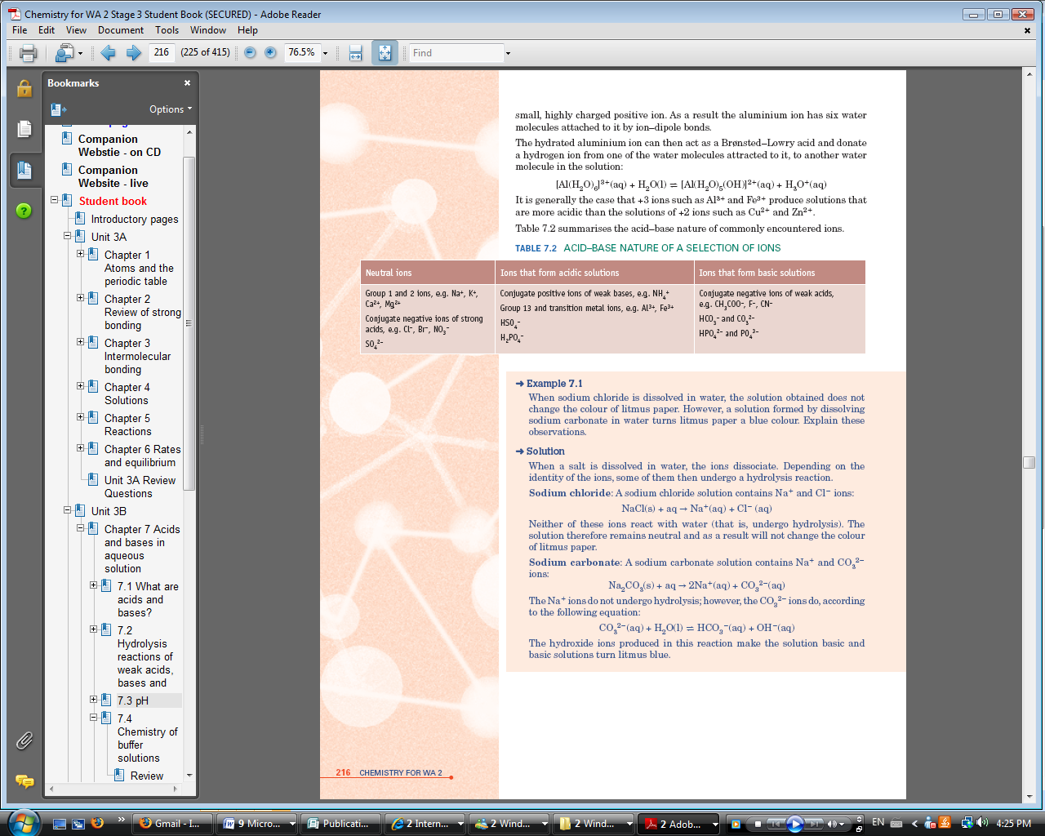The acid–base properties of ions are summarised in the table below

A substance that can behave both as an acid and a base is called amphoteric.

* + - The equilibrium constant for the self-ionisation of water is the self-ionisation constant, *K*w:

[H3O+][OH-] = *K*w = 1.0 × 10-14 at 25°C

* + - In a neutral solution, at any temperature [H3O+] = [OH-].
* In an acidic solution [H3O+] > [OH-] and in a basic solution [OH-] > [H3O+].
  + - At 25°C,
    - in a neutral solution [H3O+] = [OH-] = 1 × 10-7 mol L-1
    - in an acidic solution [H3O+] > 1 × 10-7 mol L-1
      * in a basic solution [OH-] > 1 × 10-7 mol L-1
    - The value of *K*w changes with temperature. The self ionisation reaction of water is endothermic, so *K*w increases with increasing temperature and decreases with decreasing temperature.
    - pH = –log10[H3O+]
    - At 25°C, a neutral solution has a pH of 7, an acidic solution, pH less than 7 and a basic solution, pH greater than 7.

**Buffers**

* + - A buffer is a solution that resists a change in its pH when small amounts of an acid or base are added.
    - A buffer solution consists of a mixture of a weak acid and its conjugate base.
    - The extent to which the buffer can ‘absorb’ the extra acid or base added is called the buffer capacity.
    - The buffer capacity depends on the concentrations of the weak acid and its conjugate base. The best buffering capacity is obtained if the concentrations are large and approximately equal to one another. The buffering capacity us the ability of a buffer solution to resist a pH change.
    - The buffer system in the blood depends on the equilibria:

H3O+(aq) + HCO3-(aq) ⇌ H2O(l) + H2CO3(aq) ⇌2H2O(l) + CO2(g)

* The buffer range is the range of pH the buffer solution can tolerate e.g.,. the buffer range of blood is between the pH’s of 7.37 and 7.43
  + - Buffer solutions are used to calibrate pH meters because the pH of the solution remains approximately the same despite a small degree of contamination n.

**TITRATIONS**

|  |  |
| --- | --- |
| **Terms** | **Definition** |
| **Pipette** | A piece of analytical equipment that allows delivery of an accurately known volume of solution |
| **Burette** | A piece of analytical equipment with a graduated scale and a tap to allow delivery of a variable volume of solution |
| **Volumetric Flask** | A flask for use in volumetric analysis that contains a specified volume when filled to an indicated level |
| **Primary Standard** | A substance that can be used directly to prepare a standard solution. The substance has a known formula, is obtainable in pure form and is stable over time |
| **Secondary Standard** | A solution that has been titrated against a primary standard.( A standard solution is a secondary standard) |
| **Desiccator** | A tightly closed container charged with a suitable desiccant (commonly CaCl2 or CaSO4) that allows an atmosphere of low humidity to be maintained. |
| **Titration** | The procedure where one solution is added to another solution until the reaction between them is complete on has a known concentration |
| **Aliquot** | The volume of a solution delivered by pipette. |
| **Titre** | The volume of solution delivered by a burette during a titration |
| **Meniscus** | The shape assumed by the surface of a liquid in a cylindrical container |
| **Equivalence Point** | The point during a reaction at which stoichiometric amounts of the reactants have been mixed |
| **Indicator** | A weak acid and its conjugate base, at least one of which is highly coloured used to indicate equivalence point |
| **End Point** | The point during a reaction where an indicator changes colour to show the reaction is complete |
| **Deliquescent** | The term given to a solid that absorbs water from the atmosphere and dissolves in water |

A Primary Standard Solution must be:

* Obtained pure
* Have a known formula
* Note react with surroundings
* Have a high molar mass
* Maintain a constant concentration over a long period of time

In titration between HCL and NAOH where HCL is in the burette and the NaOH is in the conical flask what solution is used to wash or rinse each of the following pieces of equipment before use:

1. Pipette: NaOH b)Volumetric Flask: Distilled Waterc) Burette: HCl

Equivalence points:

|  |  |  |  |  |  |
| --- | --- | --- | --- | --- | --- |
| **Acid** | **Base** | **Equivalence pH** | **Indicator** | **Colour Change** | **Example** |
| Strong | Strong | Neutral | Phenolphthalein | Colourless to pink | HCl and NaOH |
| Weak | Weak | Neutral | Phenolphthalein | Colourless to pink | CH3COOH and NH3 |
| Strong | Weak | Acidic | Methyl Orange | Red to yellow | HCl and NH3 |
| Weak | Strong | Basic | Phenolphthalein | Colourless to pink | CH3COOH and NaOH |

**Redox Reactions**

A redox reaction involves a transfer of electrons between some species in the reaction. For a chemical change to be redox both oxidation and reduction must occur. A redox reaction occurs only if there is a change in oxidation number.

|  |  |
| --- | --- |
| **Oxidation** | **Reduction** |
| The loss or donation of electrons | A gain or acceptance of electrons |
| An increase in the oxidation number | A decrease in oxidation number |

* An oxidising agent or oxidant causes the oxidation of another species and is itself reduced.
* A reducing agent or reductant causes the reduction of another species and is itself oxidised.

Rules of Oxidation numbers

1. Atoms in the free state have and oxidation number of 0 (i.e. O2,N2 or Mg(s))
2. Monatomic ions have an oxidation number equal to their charge
3. For polyatomic ions the sum of the oxidation numbers of all the atoms equals the charge on the ion or molecule
4. Hydrogen atoms bonded to other elements have an oxidation number of +1 except metal hydrides where the oxidation number is -1
5. Oxygen atoms bonded to other elements, have an oxidation number of -2 except peroxides where the oxidation number is -1 or in fluorine oxide where the oxidation number is +2

* Oxidation number is a real or imaginary charge on an atom which indicates its state of oxidation. It is the property of a single atom. True even if the atom is part of a cluster of atoms that collectively form a polyatomic ions or molecule. The oxidation number can be defined as the charge the atoms would have if the bonds to it were purely ionic
* Disproportionation involves the simultaneous oxidation and reduction of a reactant in a redox reaction. A substance which can be both oxidised and reduced simultaneously is said to undergo disproportionation. For example in the decomposition of hydrogen peroxide oxygen undergoes disproportionation

2H2O2 => 2H2O(l) + O2(g)

The oxidation number of oxygen goes from -1 to -2 and -1 to 0. Therefore it is both oxidised and reduced, going through disproportionation

* An oxidation half-equation shows loss of electrons. A reduction half-equation shows gain of electrons. An oxidation half equation has electrons on the right side of the equation. A reduction half equation has electrons on the left side of the equation
* A redox equation is obtained by adding half-equations that have been multiplied by factors so that the number of electrons is the same in both half-equations.
* When balancing a simple redox reaction split it into its half equations and add electrons as needed on whichever side they are needed. To obtain the final redox equation “add” the two equations up, multiplying the equations by any coefficients that are needed so as to get rid of the electrons (look at sequential reactions if you’re confused).
* An activity series for metals ranks them in order from the most reactive (strongest reductant) to least reactive. Metals higher in the series can donate electrons to ions of metals lower in the series.
* An activity series for halogens ranks them in order from the most reactive (strongest oxidant) to least reactive. Halogens higher in the series can take electrons from ions of halogens (halides) lower in the series.
* In the periodic table atoms get smaller across the period and bigger down each group, this is why the strongest oxidising agent is fluorine as it is one of the smallest elements.
* When balancing a harder redox equation (acidic solution)you may need to add H+ ions or H2O molecules as shown below.

Balance the redox equation: SO32- +IO3- +H+ => I2 +SO42- + H2O

|  |  |  |
| --- | --- | --- |
| Find the pairs: | SO32- => SO42- | IO3-=> I2 |
| Find what is needed: | Needs oxygen on left side. To balance oxygen’s we add water. | Needs oxygen on right side, IO3- needs 2 iodine’s |
| Add what is needed: | SO3­2- +H2O => SO42- | 2IO3- => I2 + 6H2O |
| Find what is needed | Hydrogen ions on right side | Hydrogen ions on left side |
| Add what is needed: | SO32-+H2O => SO42-+2H+ | 2IO3- + 12H+ => I2+6H2O |
| Figure out electrons needed by trying to balance charge on both sides: | -2+0=-2 -2+2=0  .: Right side needs two electrons .: Oxidation | -2+12 = 10 0+0=0  .: left side of equation needs 10 electrons .: Reduction |
| Add electrons | SO3­2- + H2O => SO42-+2H++2e- | 2IO3- + 12H++10e- => I2+6H2O |
| Balance electrons so that they will be cancelled: | SO3­2- + H2O => SO42-+2H++2e-[x 5]  5SO3­2- + 5H2O => 5SO42-+10H++10e- | Leave |
| “Add”up the two equations | 5SO3­2- + ~~5H~~~~2~~~~O~~ => 5SO42-+~~10H~~~~+~~+~~10e~~~~-~~  2IO3- + 2H+~~12H+~~+~~10e~~~~-~~ => I2+~~6H~~~~2~~~~O~~ 1H2O | |
| Final equation: | 5SO3­2-+2IO3- + 2H+ => 5SO42-+ I2 + H2O | |

* Reduction potentials can be used to determine if a reaction occurs or not, in a list of reduction potentials the oxidation potential of that element/compound will be the reverse reaction therefore the negative voltage.
* Oxidation is defined as a loss of electrons, while reduction is a gain of electrons.
* Reductants undergo oxidation. Oxidants undergo reduction.
* An oxidation number is a number that is assigned to each atom in a substance to indicate its oxidation state.
* In a reaction, oxidation is an increase in oxidation number and reduction is a decrease in oxidation number.
* A half-equation for an oxidation or reduction reaction can be written using the following rules:
  1. Write the formula of the oxidant or reductant, and the product it forms.
  2. Balance the atom undergoing the change in oxidation number.
  3. Balance oxygen atoms by adding water, H2O, where needed.
  4. Balance hydrogen atoms by adding H+ where needed.
  5. Balance the charge by adding electrons where needed.
* An ionic equation for a redox reaction can be written by adding the two relevant half-equations, ensuring the electrons cancel out.
* Common oxidants include O2, Cl2, MnO4 -, Cr2O7 2-, ClO-, H+, concentrated H2SO4 and HNO3.
* Common reductants include Zn, H2, Fe2+ and C2O4 2-.

**Redox Titrations**

* A redox titration involves a reaction between two solutions, one containing an oxidising agent the other a reducing agent. The concentration of one solution must be accurately known. This is called the standard solution. The other solution is of unknown concentration. The purpose of the titration is to find the concentration of the reducing agent or oxidising agent in the solution of unknown concentration.

|  |  |
| --- | --- |
| **Terms** | **Definition** |
| **Pipette** | A piece of analytical equipment that allows delivery of an accurately known volume of solution |
| **Burette** | A piece of analytical equipment with a graduated scale and a tap to allow delivery of a variable volume of solution |
| **Volumetric Flask** | A flask for use in volumetric analysis that contains a specified volume when filled to an indicated level |
| **Primary Standard** | A substance that can be used directly to prepare a standard solution. The substance has a known formula, is obtainable in pure form and is stable over time |
| **Secondary Standard** | A solution that has been titrated against a primary standard.( A standard solution is a secondary standard) |
| **Desiccator** | A tightly closed container charged with a suitable desiccant (commonly CaCl2 or CaSO4) that allows an atmosphere of low humidity to be maintained. |
| **Titration** | The procedure where one solution is added to another solution until the reaction between them is complete on has a known concentration |
| **Aliquot** | The volume of a solution delivered by pipette. |
| **Titre** | The volume of solution delivered by a burette during a titration |
| **Meniscus** | The shape assumed by the surface of a liquid in a cylindrical container |
| **Equivalence Point** | The point during a reaction at which stoichiometric amounts of the reactants have been mixed |
| **Indicator** | Ina redox reaction there is no indicator involved, but one of the solutions is coloured and generally a colour change indicates the endpoint e.g. in a titration between acidified KMnO4 and H2C2O4 the colourless oxalic acid becomes slightly pink indicating the end point |
| **End Point** | The point during a reaction where one of the reactants changes colour to show the reaction is complete |
| **Deliquescent** | The term given to a solid that absorbs water from the atmosphere and dissolves in water |

* Common Primary standards for redox titrations are oxalic acid (H2C2O4.2H2O) and ammonium iron(II) sulphate.[(NH4)2Fe(SO4)2.2H2O­)

|  |  |  |  |
| --- | --- | --- | --- |
| **Primary Standard** | **Formula** | **Active Species** | **Half equation** |
| Ammonium iron(II) sulphate | (NH4)2Fe(SO4)2.2H2O­ | Fe2+ | Fe2+->Fe3++e- |
| Oxalic acid | H2C2O4.2H2O | H2C2O4 | H2C2O4->2CO2+2H+ +2e- |

General Procedure:

1. Pipette 20mL of reagent into a 100mL beaker and dissolve in about 50mL
2. Pour into 500mL volumetric flask and rinse beaker into flask thoroughly 3 to 4 times.
3. Fill volumetric flask up until the mark so that the bottom of the meniscus aligns with the mark. Make sure to close the bottle
4. Making sure that the tap is closed, put the filter funnel into the top of the burette and pour in the second reagentto about half way.
5. Flush all the solution out into a second 100mL beaker. Make sure not to reuse this solution
6. Close the tap and pour more of the second reagent into the burette.
7. Wash the pipette with distilled water.
8. Pipette 20mL of the first reagent into a conical flask and add about 15mL of acid.
9. Place the conical flask under the burette and measure the initial volume in the burette
10. Add the second reagent drop wise until a persistent pink colour change occurs.
11. Record the final volume and calculate the titration volume. Use this as rough estimate for your titration volume
12. Repeat steps 9 to 12 remembering to wash the conical flask with distilled water and make sure to be very accurate during the titration, adding drop wise as you reach the estimated titration volume. Make sure that there is enough of the second reagent to complete one titration

**Electrochemical Cells**

* In an electrochemical cell a spontaneous redox reaction occurs and chemical energy is converted to electrical energy.
* The electrochemical cell comprises two half-cells, one containing the reductant and the other the oxidant. The half-cells are connected by a wire (the external circuit) and a salt bridge (part of the internal circuit).
* In each half-cell there is an electrode and an electrolyte.
* The cell potential of an electrochemical cell is measured in volts and it depends on the nature of the half-cell reactions and the concentrations/gas pressures of the reacting substances.
* In an electrochemical cell, oxidation occurs at one electrode called the anode. It is the negative electrode. Reduction occurs at the other electrode, called the cathode. It is the positive electrode.
* When an electrochemical cell is discharging (producing electrical energy), electrons flow in the external circuit and ions move internally in the electrolyte between the electrodes.
* In the salt bridge in an electrochemical cell, the positive ions (cations) fl ow towards the positive electrode (cathode) and the negative ions (anions) flow towards the negative electrode (anode).
* Standard reduction potentials (*E*°) are a measure of the tendency of a substance to be reduced under standard conditions. They are measured in volts. The hydrogen half-cell is the standard reference with an *E*° of 0.00 V.
* The strongest oxidants have the highest reduction potentials. The strongest reductants occur at the bottom right of the table of standard reduction potentials.
* In an electrochemical cell, the electrons flow through the external circuit towards the cell with the stronger oxidant (from anode to cathode).
* The cell potential (potential difference or voltage) of an electrochemical cell is the difference in the reduction potentials of the half-cells comprising the cell:

*E*cell = *E*oxidant – *E*reductant

* A spontaneous redox reaction will occur between two substances if:
  1. one reactant is an oxidant and the other is a reductant
  2. the oxidant has a more positive standard reduction potential (*E*°) than the reductant.

**Applications Of Redox**

* A cell or a battery is an electrochemical cell that stores useful energy in the form of an oxidant and a reductant that are capable of releasing electrical energy when required.
* Primary cells are cells in which the spontaneous redox reaction cannot be reversed.
* Secondary cells can be recharged by passing a current through them to convert products back to reactants.
* In the dry cell (or Leclanché cell), the anode consists of a zinc container while the cathode is a graphite rod surrounded by powdered manganese dioxide, MnO2. The electrolyte is a moist paste of NH4Cl and ZnCl2. The electrode reactions are:

Anode: Zn(s) → Zn2+(aq) +2e-

Cathode: 2MnO2(s) + 2NH4+(aq) + 2e- → Mn2O3(s) + 2NH3(aq) + H2O(l)

Or

MnO2(s) + NH4+(aq) +H2O+e- → Mn(OH)3(s) + NH3(aq)

* The dry cell has a limited shelf life, produces a voltage of around 1.5 V and cannot be recharged.
* The lead–acid accumulator, used in vehicles, is an example of a secondary battery.
* The lead–acid accumulator is made up of cells consisting of an anode of lead and a cathode of a lead grid packed with lead(IV) oxide, PbO2.The electrolyte is sulfuric acid.
* During the discharging process, chemical energy is changed to electrical energy in the battery.

Anode: Pb(s) + SO4 2-(aq) → PbSO4(s) + 2e-

Cathode: PbO2(s) + SO42-(aq) + 4H+(aq) + 2e- → PbSO4(s) + 2H2O(l)

* The overall discharging reaction is:

Pb(s) + PbO2(s) + 4H+(aq) + 2SO42-(aq) → 2PbSO4(s) + 2H2O(l)

* A fully charged car battery has a total cell potential of about 12 V.
* The recharging reaction is:

2PbSO4(s) + 2H2O(l) → Pb(s) + PbO2(s) + 4H+(aq) + 2SO42-(aq)

* Other commercially available cells include zinc/silver oxide, nickel–cadmium and lithium ion batteries.
* In a fuel cell, the reactants are supplied continuously (and the products removed continuously) to the electrodes.
* The most common fuel cell is based on the reaction between hydrogen and oxygen to form water.
* The electrodes are porous, compressed carbon containing a suitable catalyst. The electrolyte may be either hydrochloric acid or potassium hydroxide solution.
* The electrode reactions in this fuel cell are:

With an acid electrolyte

Anode: H2(g) → 2H+(aq) + 2e-

Cathode: O2(g) + 4H+(aq) + 4e- → 2H2O(l)

With an alkaline electrolyte

Anode: H2(g) + 2OH-(aq) → 2H2O(l) + 2e-

Cathode: O2(g) + 2H2O(l) + 4e- → 4OH-(aq)

* The overall reaction, for both electrolytes, is:

2H2(g) + O2(g) → 2H2O(l)

* Some metals such as aluminium are protected from corrosion by impervious oxide layers.
* Rusting of iron occurs in the presence of oxygen and water.
* Factors such as impurities in the iron and the presence of electrolytes dissolved in the water enhance the rate of the rusting process.

**Corrosion**

* Corrosion in the presence of water has an electrochemical nature because the oxidation and reduction processes can take place at different points on the metal.
* In the corrosion of iron, the half-reactions are:

Anode: Fe(s) → Fe2+(aq) + 2e-

Cathode: O2(g) + 2H2O(l) + 4e- → 4OH-(aq)

The iron(II) ions and hydroxide ions diffuse towards each other and precipitate as iron(II) hydroxide:

Fe2+(aq) + 2OH-(aq) → Fe(OH)2(s)

The iron(II) hydroxide is oxidised by air to form iron(III) hydroxide:

Fe(OH)2(s) + OH-(aq) → Fe(OH)3(s) + e-

The iron(III) hydroxide is then partially dehydrated to give rust, Fe2O3·*x*H2O.

* The overall equation for the rusting of iron is:

4Fe(s) + 3O2(g) + 2*x*H2O(l) → 2Fe2O3·*x*H2O(s)

* The following methods can be used to prevent rusting:
* application of a surface coating that prevents oxygen and water from coming in contact with the iron. If a less reactive metal is used, the rusting process increases if the coating is scratched
* galvanising the surface of the metal with a coating of a more reactive metal that is oxidised more readily than the iron
* connecting the iron or steel, by a conducting wire, to a piece of more reactive metal
* making the iron or steel the cathode of an electrolytic cell—called cathodic protection.

Factors affecting the rate of corrosion of iron include:

* Oxygen: Must be present for corrosion to occur. The higher the concentration of oxygen, the faster the rate of corrosion
* Water: Must be present for corrosion to occur. In the absence of water corrosion of iron won’t happen.
* pH: The lower the pH of water, i.e. the more acidic it is the greater the rate of corrosion. This happens as the reduction potential of oxygen increases as pH decreases.
* Electrolytes: Electrolytes provide an efficient salt ridge between the anodic and cathodic sites of corrosion. The presence of these speeds up the corrosion process. Rusting in or near marine environments is much faster than away from salt areas
* Less reactive metals: Where iron contacts a less reactive metal, it corrodes faster e.g. screwing a copper pipe to a steel frame makes the steel frame corrode faster.
* More reactive metals: Contact with a more reactive metal prevents iron from corroding e.g. bolting a piece of magnesium to a ships’ steel hull prevents the hull from corroding.
* Temperature: As with all reactions, a higher temperature leads to a higher reaction rate.

Methods of corrosion control apply the principles of collision theory and reaction rate by excluding or reducing concentration of reactants like oxygen and water. Principles of electrochemistry are also relevant in managing corrosion.

|  |  |
| --- | --- |
| **Method** | **How it works** |
| **Inert non-metallic coatings** | Coating iron with a non-reactive non-metallic material e.g. greases, paint, plastic or porcelain. This works by excluding O2 and H2O form iron this preventing reduction and so oxidation can’t occur either. This is only effective while the barrier is intact. Once scratched, corrosion will commence |
| **Inert metallic coatings** | Coating iron with a less reactive metallic material e.g. tin or copper. This excludes O2 and H2O from iron thus preventing reduction and so oxidation cannot occur either. This only works while the barrier is fully intact. Corrosion occurs faster than normal if the metallic coating is damaged. This happens as iron is more reactive than the metal coating and iron becomes quickly oxidised, effectively protecting the less reactive metallic coating |
| **Galvanising** | Involves coating iron with the more reactive metal zinc. This method works by excluding O2 and H2O. Most importantly though, as zinc oxidises in preference to iron, due to its higher oxidation potential, it will protect the underlying iron even if the zinc is scratched and the iron is exposed to O2and H2O. This effect is known as cathodic protection. Also the zinc surface naturally forms a passivating layer of ZnCO3.Zn(OH)2 which protects the zinc layer from excessive oxidation |
| **Cathodic protection using a DC current** | This involves applying an electric current to the iron, making it the negative terminal of a DC circuit. As iron is supplied with electrons (cathodic) it can’t oxidise. The anode is attached to a piece of scrap iron, which becomes oxidised over time. Other types of anode, like those made of carbon, high silicon steel or platinum anodes, water is oxidised instead of the anode, so these last indefinitely. For cathodic protection to be effective, the anode must be in salt bridge contact with the iron structure being protected. Thus a very damp, wet environment is essential. |
| **Cathodic protection using a sacrificial anode** | Sacrificial anodes are made of metals more reactive than iron. The sacrificial is bolted tot eh iron needing protection and must be in salt bridge contact with the iron. Thus sacrificial anodes only work in a very damp or wet environment, eg eater storage tanks, ships’ hulls or underground pipelines, This process works as the more reactive metal of the sacrificial anode is oxidised in preference to iron, As the sacrificial anode slowly oxidises it releases electrons onto the iron surface and makes the iron cathodic, so it can’t oxidise. As the sacrificial anode is eventually fully oxidised, it must periodically be replaced for the protection to continue |

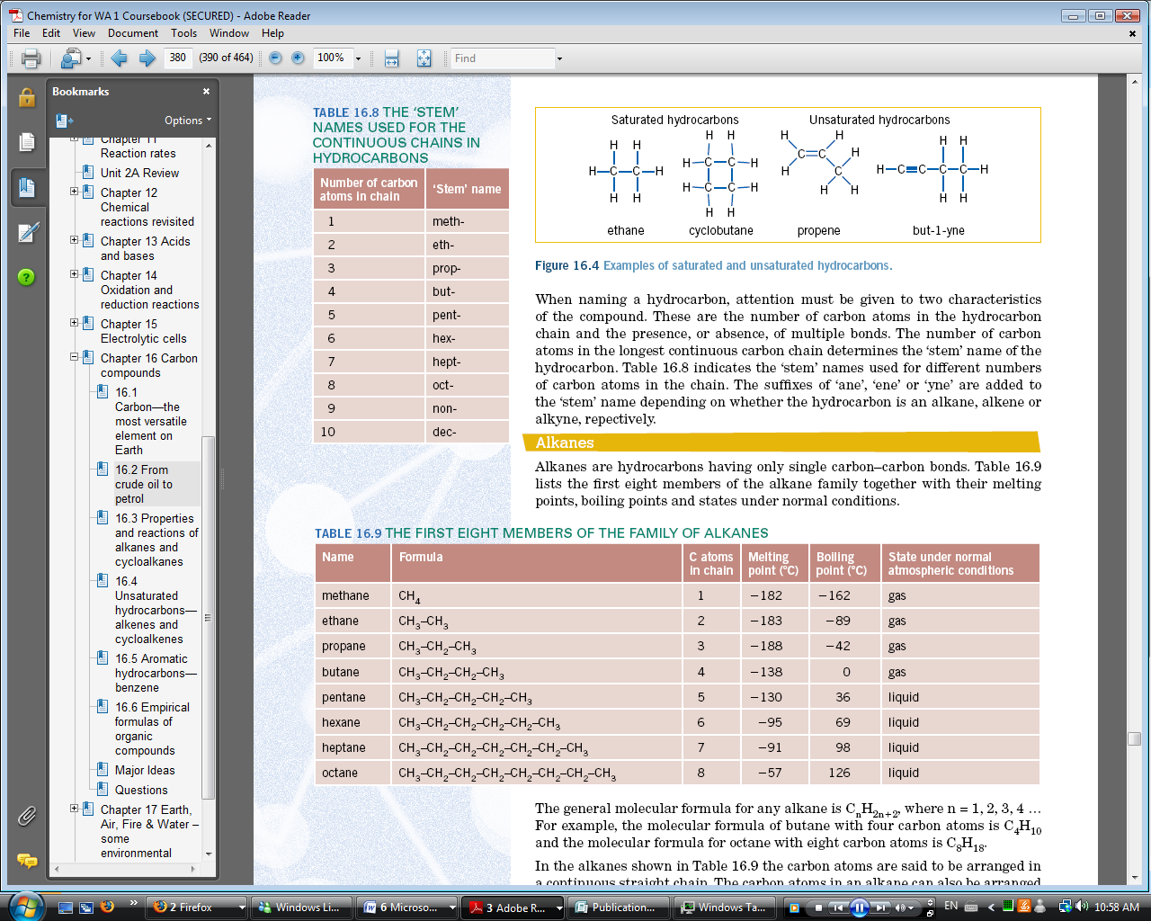**ORGANIC CHEMISTRY**

* Hydrocarbons are compounds that contain just carbon and hydrogen. Hydrocarbons can be classified into a number of categories, some of which are alkanes, cycloalkanes, alkene and cycloalkenes.
* Organic chemistry is the study of carbon compounds, particularly those involving carbon bonded to hydrogen.
* Carbon’s capacity to form four covalent bonds, to form chains and rings, to bond with many other elements, and to form multiple bonds makes it unique among the elements.
* Molecular formulas of organic compounds can be written as structural formulas, giving information about the order in which the atoms are arranged.
* Some of the carbon in the carbon cycle, particularly the carbon associated with plants and animals, has been locked away over millions of years as the fossil fuels—natural gas, crude oil and coal.
* Saturated Hydrocarbons – contain only carbon – carbon single bonds. Saturated hydrocarbons include alkanes and cycloalkanes.
* Unsaturated Hydrocarbons – have at least one multiple (double or triple) bond present.

**ALKANES**

* Hydrocarbons, particularly the alkanes, are the major constituent of crude oil.
* Alkanes are hydrocarbons having only single carbon – carbon bonds
* The general formula for any alkane is CnH2n+2 where n=1,2,3,4… e.g. butane with 4 carbon atoms is C4H10 while octane is C8H18.
* In alkanes the carbon atoms are arranged in a continuous straight chain. The carbon atoms in an alkane can also be arranged in a branched chain or in a ring. Alkanes are saturated hydrocarbons.
* 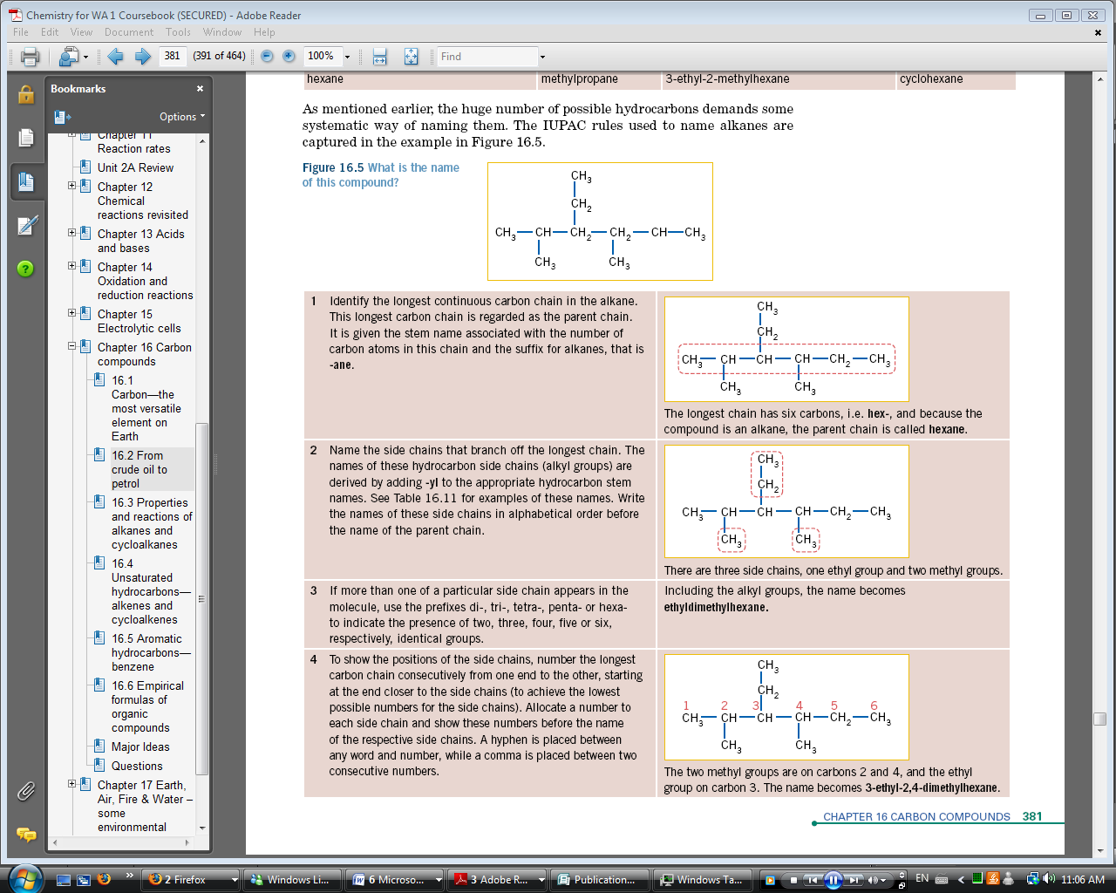The huge number of possible hydrocarbons demands some systematic way of naming them, The IUPAC rules used to name alkanes are given below

Priority of branches in any organic compound:

1. Alkenes
2. Halogens
3. Alkyl groups

For cyclic alkanes or cyclo alkanes, the same naming rules are followed except the prefix cyclo - is used to show that the parent chain is a ring. At times the carbon and hydrogen atoms in the ring of a cycloalkane are not shown in the structural formula, instead, just single lines are used to represent the single bonds between the carbon atoms in the ring.

**N**

**A**

**M**

**I**

**N**

**G**

**A**

**L**

**K**

**A**

**N**

**E**

**S**

* 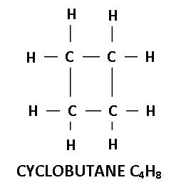Cycloalkanes have the general formula Cn­H2n­
* They from a circle like molecule:

**ISOMERISM**

* 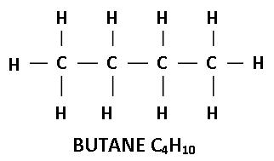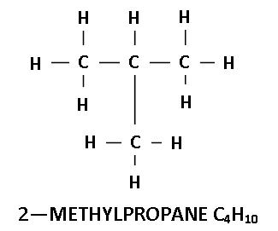Alkanes and cycloalkanes and their halogenated derivatives exhibit structural isomerism—same molecular formula but with a different arrangement of atoms.
* The 2 in front of the 2-methylpropane indicates the carbon that the methyl group stems from
* 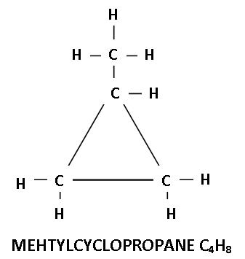Isomerism also exists in cycloalkanes. The cycloalkane with formula C4H8 could be wither cyclo butane or methylcyclopropane

**PROPERTIES**

* Low Melting Point and low boiling point
  + Melting point and Boiling point increase with increasing CH2 group addition
  + Weak forces between molecules of high molecular mass are stronger than weak forces between molecules of smaller molecular mass .: At room temperature the first four alkanes are gases, the fifth to 19th alkanes are liquids and any alkane with more than 19 carbons is solid
* Don’t dissolve in water but do dissolve in non-polar solvents. Non-polar alkane in water creates its own layer on top because it has a lower density
* Liquid alkanes help to dissolve oil-based things like oil based paints and varnishes
* It is very good for lubrication because of weak bonds between alkane molecules .: molecules are able to easily slip past each other

**REACTIONS**

**Combustion**

* Alkanes undergo combustion reactions in the presence of air or oxygen. The reactions have a high activation energy so they require ignition
* Highly exothermic=> once started there is enough heat energy to supply the activation energy.
* The exothermic nature means that alkanes are used in fuels

**Halogens**

* In the presence of UV light alkanes react with halogens, F2,Cl2, Br2 and I2.
* These reactions are relatively slow
* In these reactions:
  + C-H bonds ion the alkane are broken
  + New bonds are formed between the carbon and halogen atoms
  + This is called a substitution reaction
  + Methane can undergo a series of substitution reactions with Cl2 with UV light present to produce a mixture of haloalkanes

CH4 + Cl2 (UV light)=> CH3Cl (chloromethane)+HCl

CH3Cl + Cl2 (UV light)=> CH2Cl2 (dichloromethane)+HCl

CH2Cl2 + Cl2 (UV light)=> CHCl3 (trichloromethane)+HCl

CHCl3 + Cl2 (UV light)=> CCl4 (tetrachloromethane)+HCl

* In the presence of ultraviolet light, alkanes and cycloalkanes undergo substitution reactions to produce a range of haloalkanes or halocycloalkanes according to the general equation

R-H + X2 + UV light → R-X + H-X

**ALKENES**

* Alkenes are hydrocarbons that deal with carbon compounds that have double bonds (these can have more than one double bond). Alkenes are unsaturated hydrocarbons
* The general formula for an alkene is CnH2n
* Alkenes are used to produce plastics and polymers, pharmaceuticals and a whole range of other items we use everyday
* 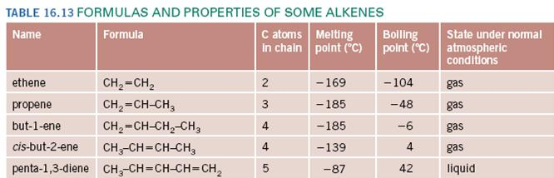In alkenes at least two carbons are joined by a double bon. This double bond gives alkenes the chemical reactivity that alkanes don’t have

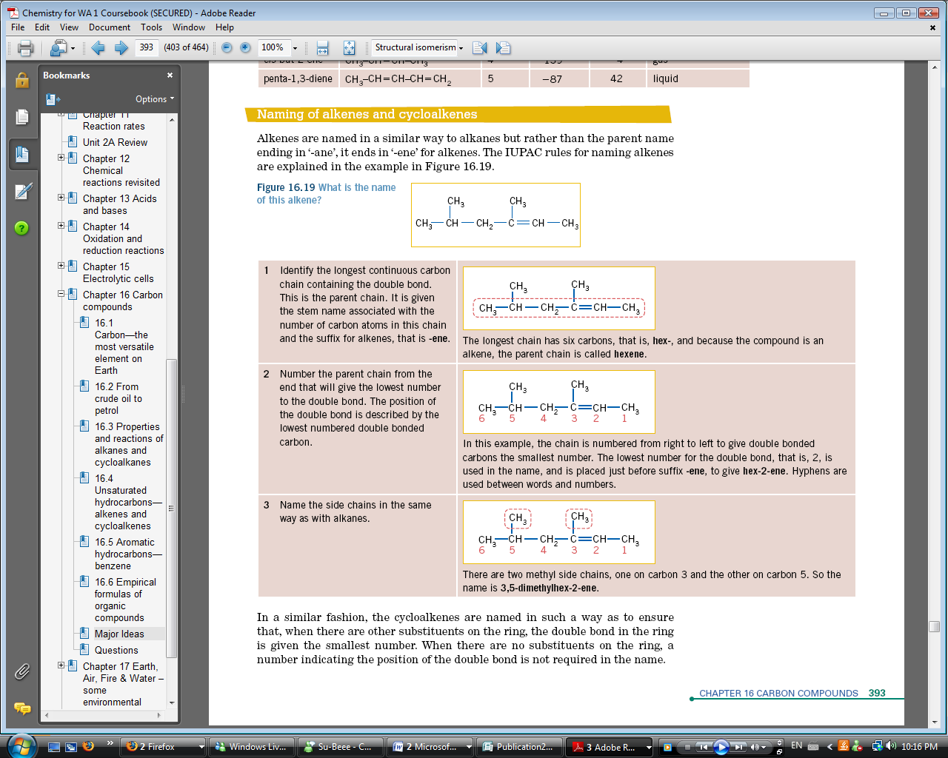**Naming Alkenes:**

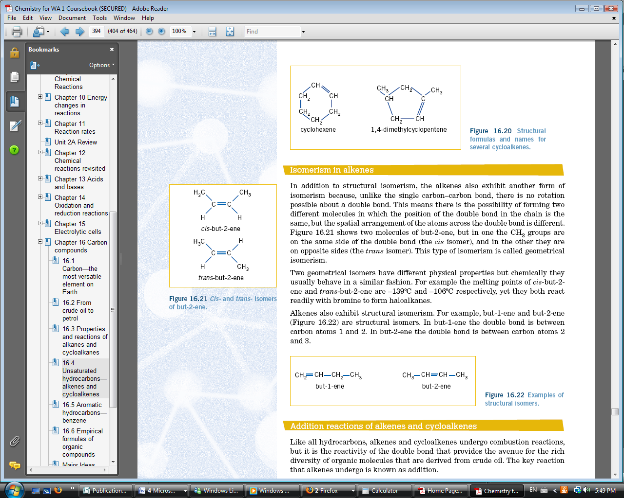**ISOMERISM**

* Alkenes show both structural isomerism as well as geometrical isomerism.
* Geometrical isomerism can be found by changing the spatial arrangement of the atoms across the double bond
* *cis­-*isomers are when both CH3 groups are on the same side of the double bond
* *trans-*isomers are when one CH3 group is on the opposite side of the double bond ot the other
* Geometric isomers have different physical properties but are chemically similar
* 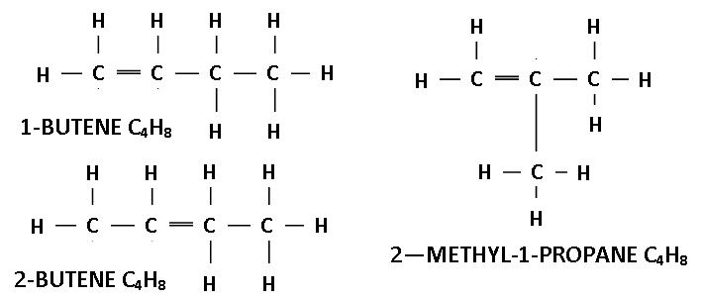Structural isomers – 1-butene and 2-butene are structural isomers but so is 2-methyl-1-propene, they all have the same formula but different structures

**REACTIONS**

**Combustion**

* All hydrocarbons undergo combustion reactions
* The reactivity of alkenes and cycloalkenes (because of the douible bond) means that there are many reactions that can take place in crude oil.
* The key reaction that alkenes go through is called addition
* In an addition reaction:
  + 2 new atoms or groups of atoms are added to the carbon on either side of the double bond
* In the reaction the double bond becomes a single bond but 2 new bonds are formed. One to each of the carbon atoms formerly joined by the double bond.
* 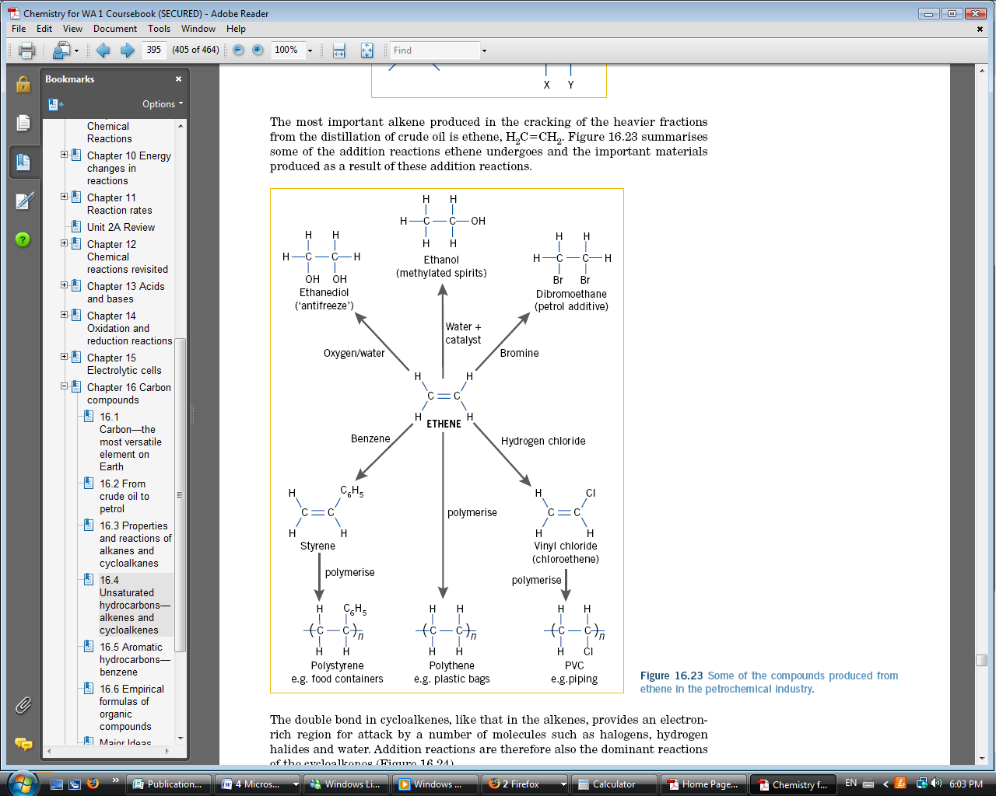Most important alkene produced in cracking of heavier fraction is ethene
* Double bonds in cycloalkenes provide an electron rich region for attack by a number of molecules such as halogens, hydrogen, halides and water .: addition reactions is dominant in cycloalkenes

**Halogenation**

* 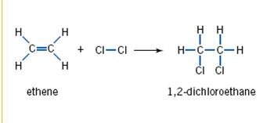Alkenes readily undergo addition reactions with the halogens to form haloalkanes. For example, ethene readily reacts with chlorine according to the following equation:
* 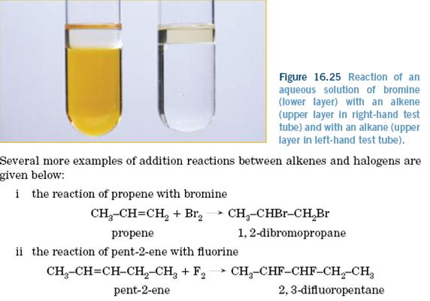The use of a coloured halogen such as red-brown bromine is a useful test for the presence of a double bond. When bromine, or a dilute solution of bromine in water, is mixed with an alkane the red-brown colour fades very slowly in the presence of ultraviolet light.
* However, in the presence of an unsaturated hydrocarbon the colour disappears very quickly as the alkene reacts with the bromine.

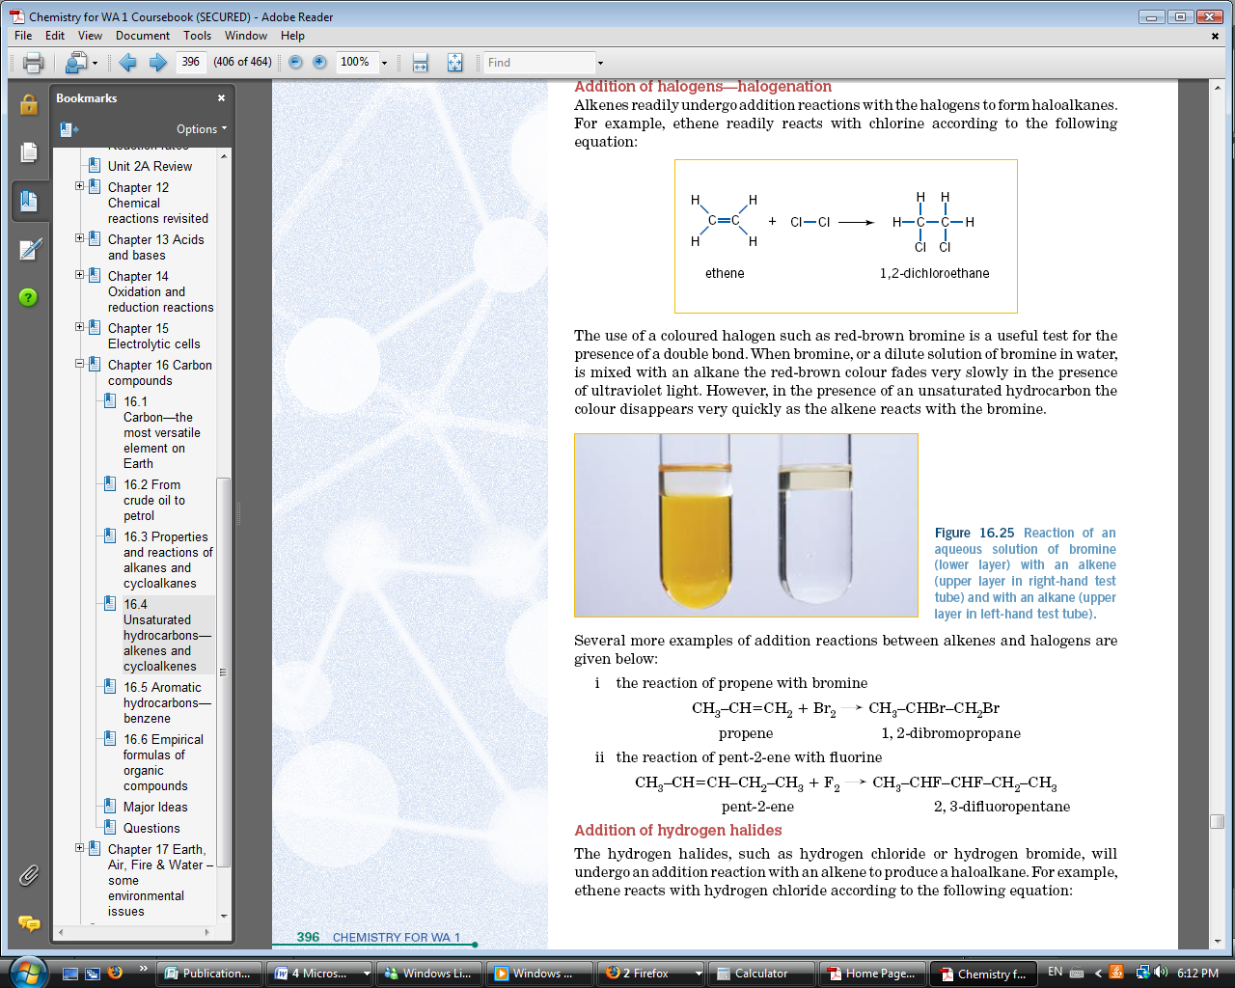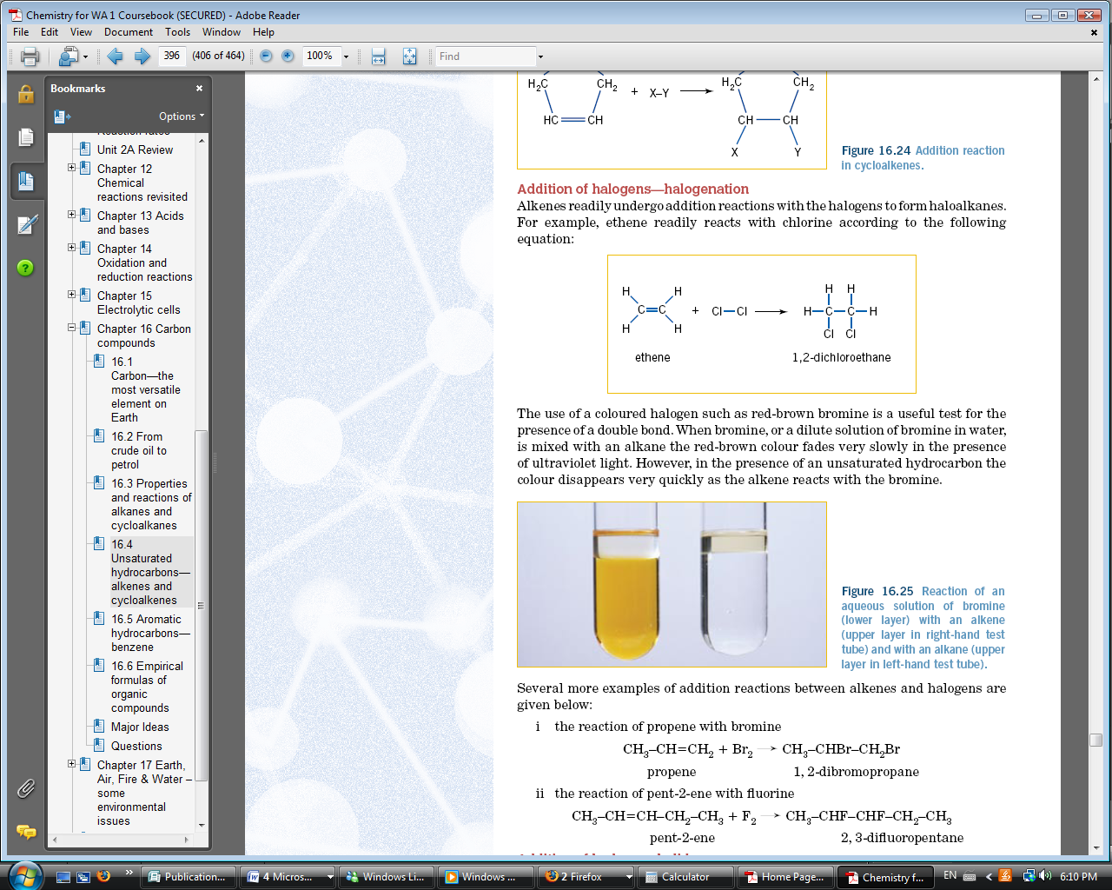**Addition of hydrogen halides**

The hydrogen halides, such as hydrogen chloride or hydrogen bromide, will undergo an addition reaction with an alkene to produce a haloalkane. For example, ethene reacts with hydrogen chloride according to the following equation:

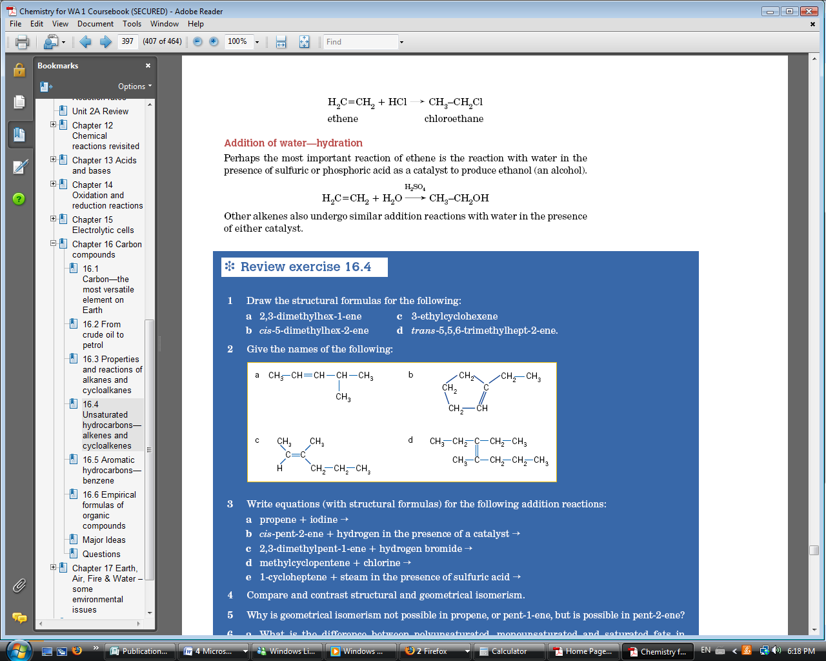**Hydration**

* Perhaps the most important reaction of ethene is the reaction with water in the presence of sulphuric or phosphoric acid as a catalyst to produce ethanol (an alcohol).

**General**

* 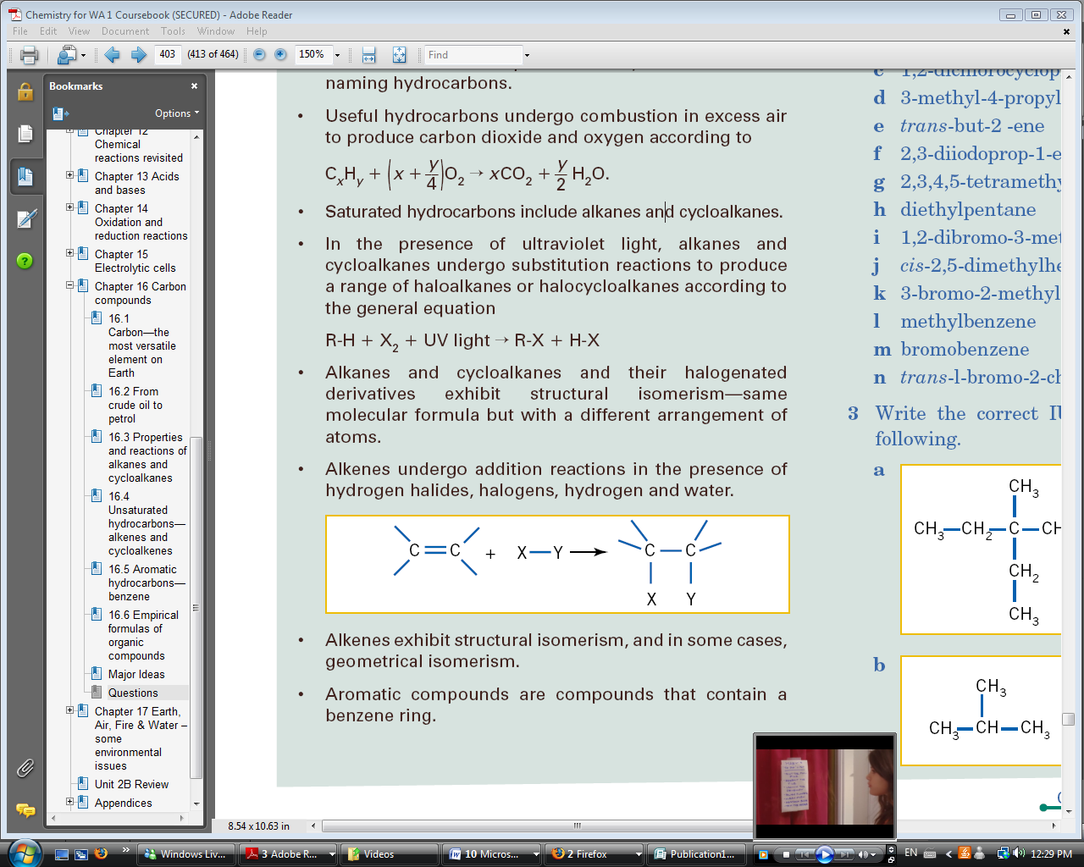Alkenes undergo addition reactions in the presence of hydrogen halides, halogens, hydrogen and water.
* Markovnikov’s rule states that “the added hydrogen atom will attach to the carbon of the multiple bond already having the most attached hydrogen atoms.”

**ALKYNES**

* General formula: CnH2n-2
* Alkynes are hydrocarbons that deal with carbon-carbon triple bonds (there can be more than one.)

**Reactions**

* Alkynes undergo addition reactions and combustion reactions in much the same way as alkenes except this time there are more bonds to add to.

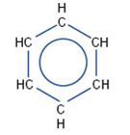**AROMATICS**

* Aromatic compounds are compounds that contain a benzene ring.
* Benzene has the formula C6H­6 and is drawn as shown in the diagram on the right 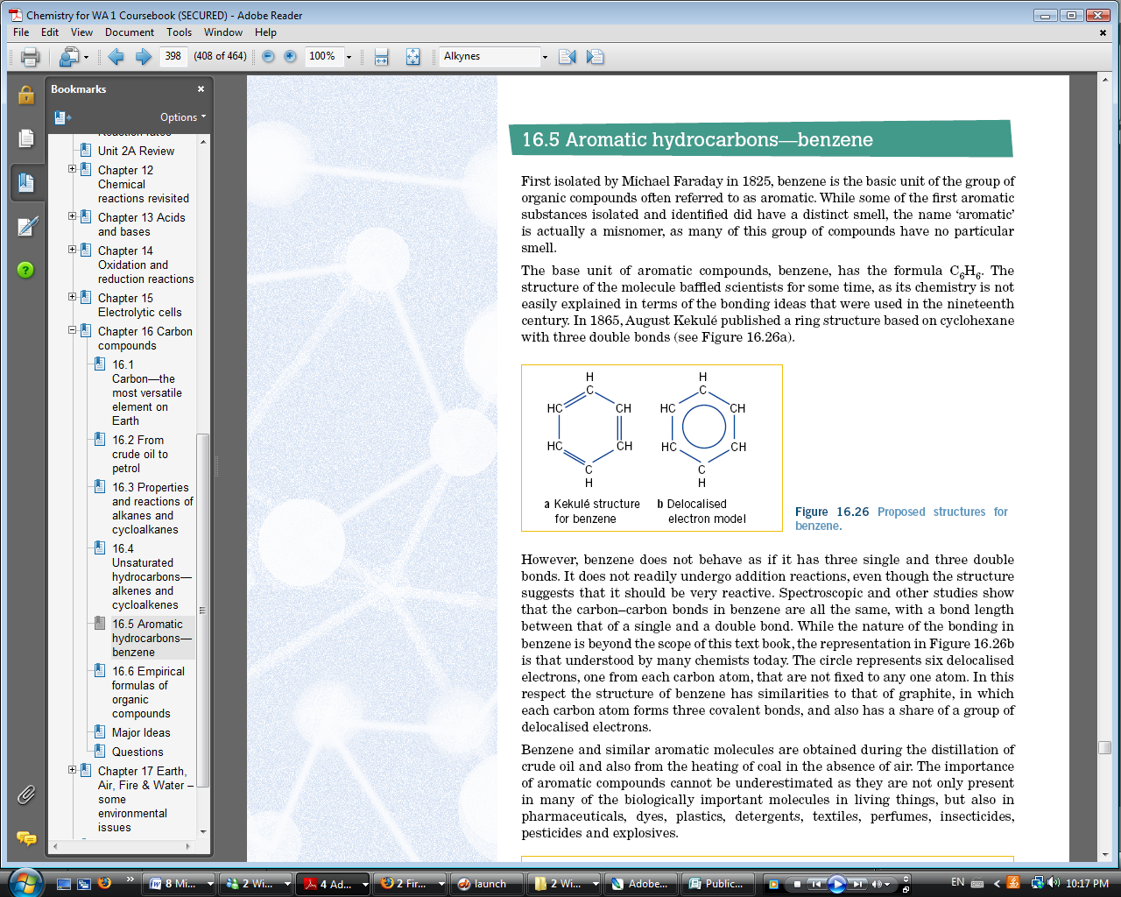
* Aromatic compounds can be found in pharmaceuticals, dyes, plastics, detergents, textilers perfumes etc;
* While some aromatic compounds do have a distinct small, the name ‘aromatic’ is actually a misnomer as many of this group of compounds have no particular smell
* Benzene contains delocalised electrons and the carbon– carbon bond is intermediate between a single and a double bond.
* Benzene does not behave as if it has 3 single and 3 double bonds.

**Naming Aromatics**

* The same rules as for alkanes applies to aromatics except that the base formula is always C6H__

**Reactions**

* Benzene doesn’t readily undergo addition reactions, even though the structure suggests that it should be very reactive.
* Benzenes reactivity reveals information about the nature of its bonds. Rather than undergoing an addition reaction, benzene undergoes mostly substitution reactions
* Benzene and other aromatic hydrocarbons undergo combustion and substitution reactions.

**Combustion**

* Burns in excess ait or O2 to produce CO2 and H2O
* Combustion of benzene: 2C6H­6(l) + 15O2(g) => 12CO2(g) + 6H2­O(g)

**Halogenation**

* In the presence of a halogen and a suitable catalyst, benzene produces a halo-substituted compound.
* Halogenation of benzene can take place at room temperature in the presence of a suitable catalyst e.g. and aluminium halide
* 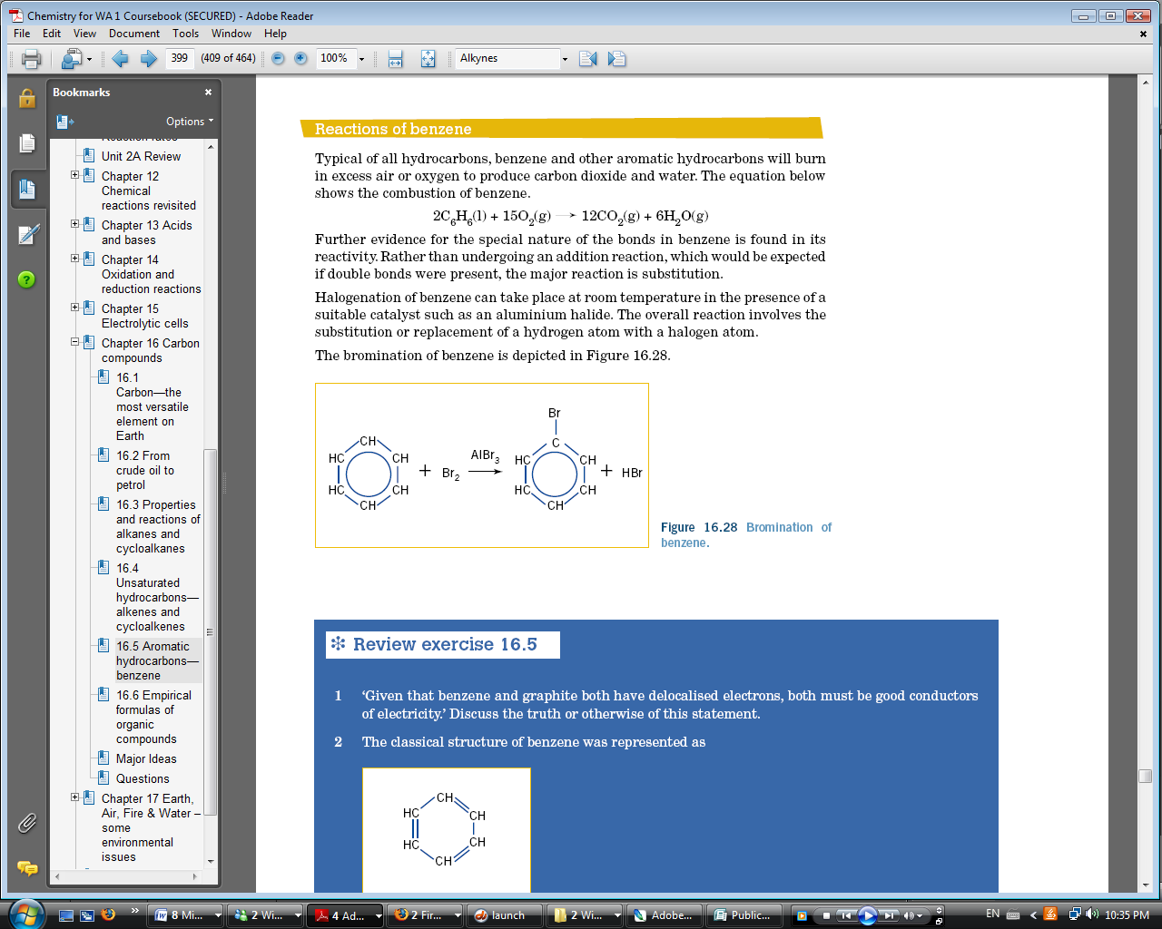Overall reaction involves the substitution or replacement of a hydrogen atom with a halogen atom.

**FUNCTIONAL GROUPS**

* A functional group is an atom or a group of atoms that determines the chemical and, in part, physical properties of a molecule.
* 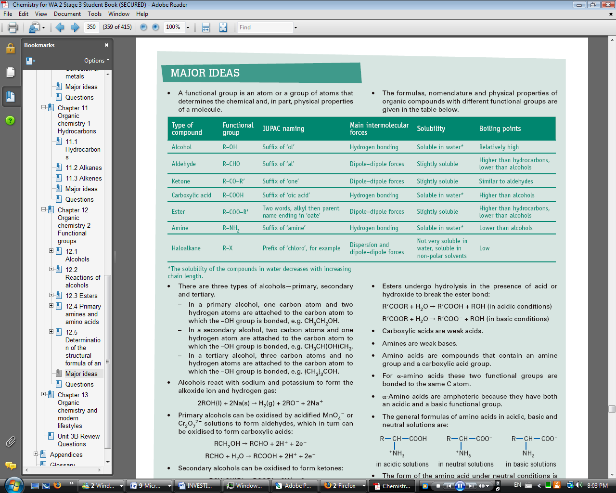The formulas, nomenclature and physical properties of organic compounds with different functional groups are given in the table below.

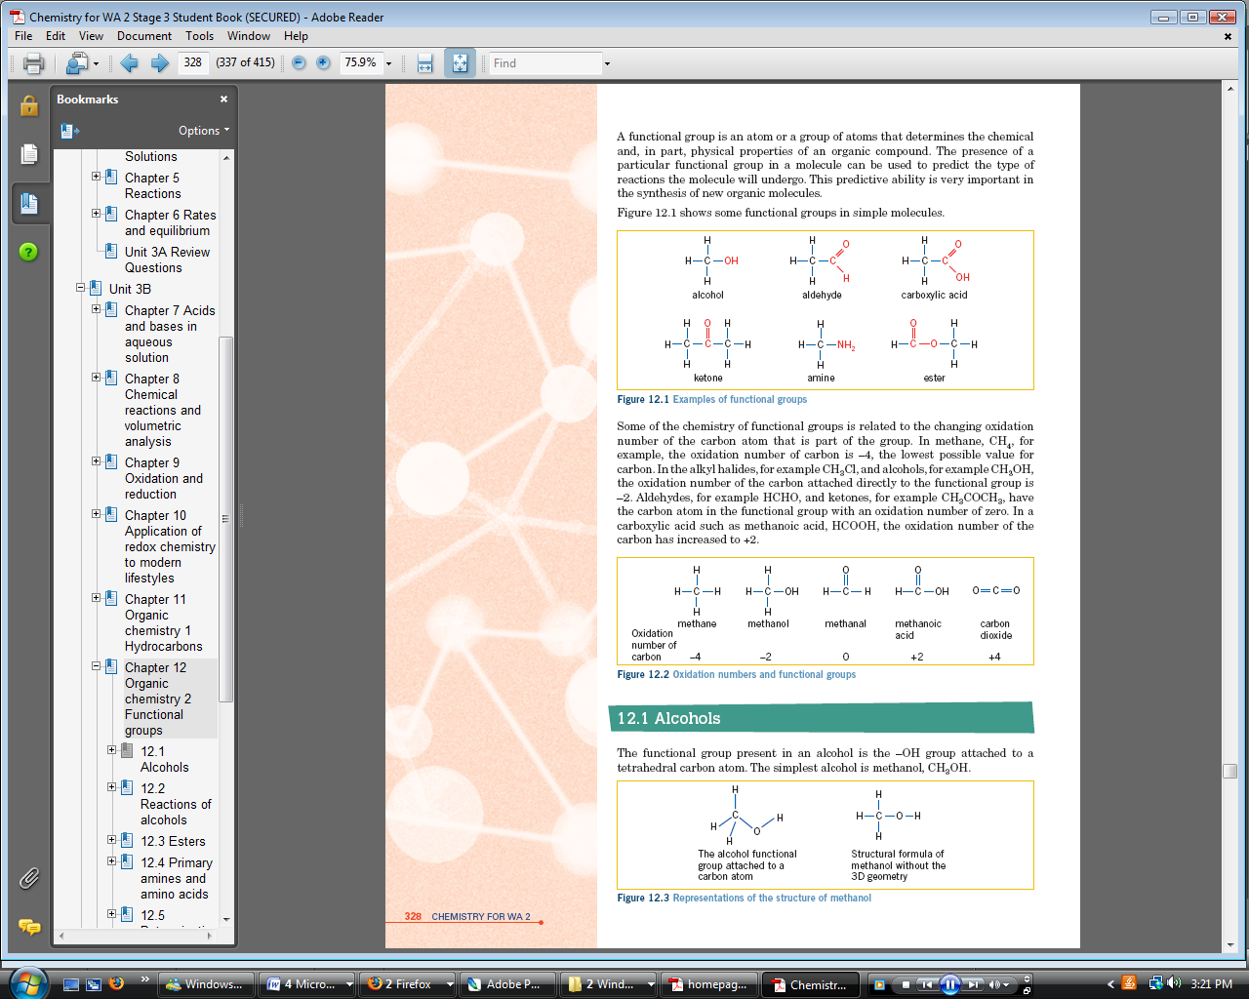

* There are three types of alcohols—primary, secondary and tertiary.
* In a primary alcohol, one carbon atom and two hydrogen atoms are attached to the carbon atom to which the –OH group is bonded, e.g. CH3CH2OH.
* In a secondary alcohol, two carbon atoms and one hydrogen atom are attached to the carbon atom to which the –OH group is bonded, e.g. CH3CH(OH)CH3.
* In a tertiary alcohol, three carbon atoms and no hydrogen atoms are attached to the carbon atom to which the –OH group is bonded, e.g. (CH3)3COH.
* Alcohols react with sodium and potassium to form the alkoxide ion and hydrogen gas:

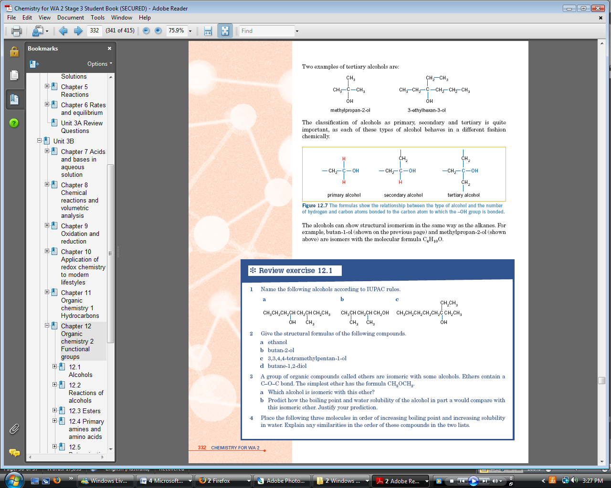2ROH(l) + 2Na(s) → H2(g) + 2RO- + 2Na+

* Primary alcohols can be oxidised by acidified MnO4 -or Cr2O7 2- solutions to form aldehydes, which in turn can be oxidised to form carboxylic acids:

RCH2OH → RCHO + 2H+ + 2e-

RCHO + H2O → RCOOH + 2H+ + 2e-

* 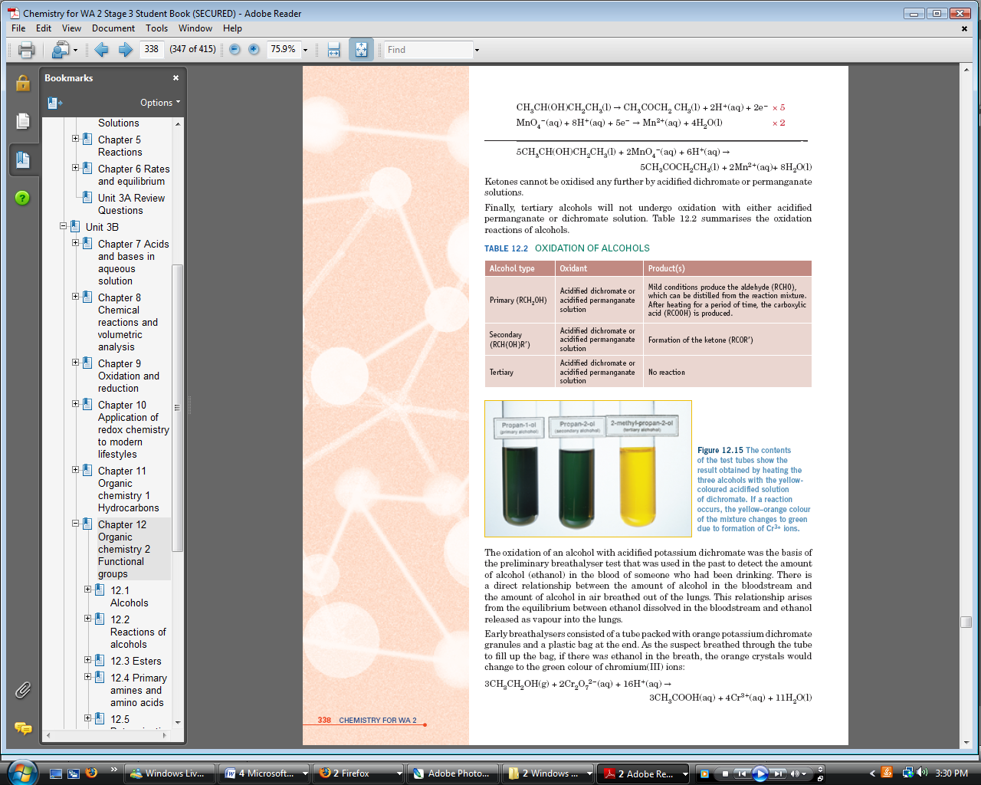Secondary alcohols can be oxidised to form ketones:

RCH(OH)R‘ → RCOR‘+ 2H++ 2e-

* Tertiary alcohols are not oxidised by acidified MnO4 - or Cr2O72- solutions.
* Alcohols react with carboxylic acid, in the presence of a catalyst, to form esters, in a condensation reaction:

H+

ROH + R’COOH =>R’COOR + H2O

* Esters undergo hydrolysis in the presence of acid or hydroxide to break the ester bond:

R’COOR + H2O → R’COOH + ROH (in acidic conditions)

R’COOR + H2O → R’COO- + ROH (in basic conditions)

* Carboxylic acids are weak acids.
* Amines are weak bases.
* Amino acids are compounds that contain an amine group and a carboxylic acid group.
* For α-amino acids these two functional groups are bonded to the same C atom.
* α-Amino acids are amphoteric because they have both an acidic and a basic functional group.
* 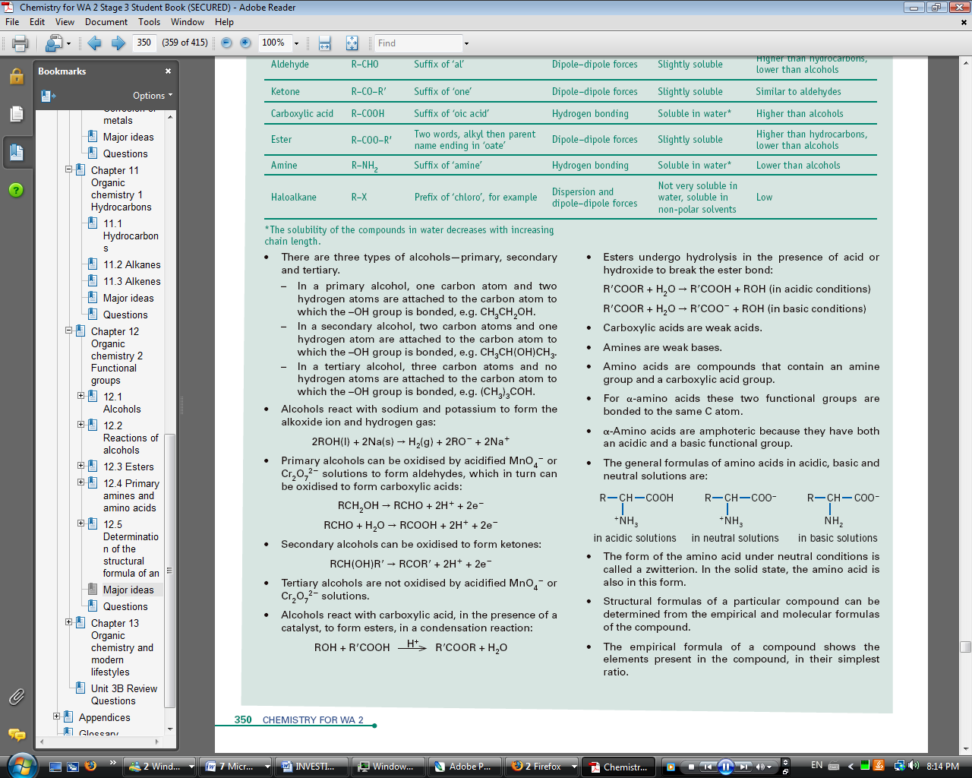The general formulas of amino acids in acidic, basic and neutral solutions are:
* The form of the amino acid under neutral conditions is called a zwitterion. In the solid state, the amino acid is also in this form.
* Structural formulas of a particular compound can be determined from the empirical and molecular formulas of the compound.

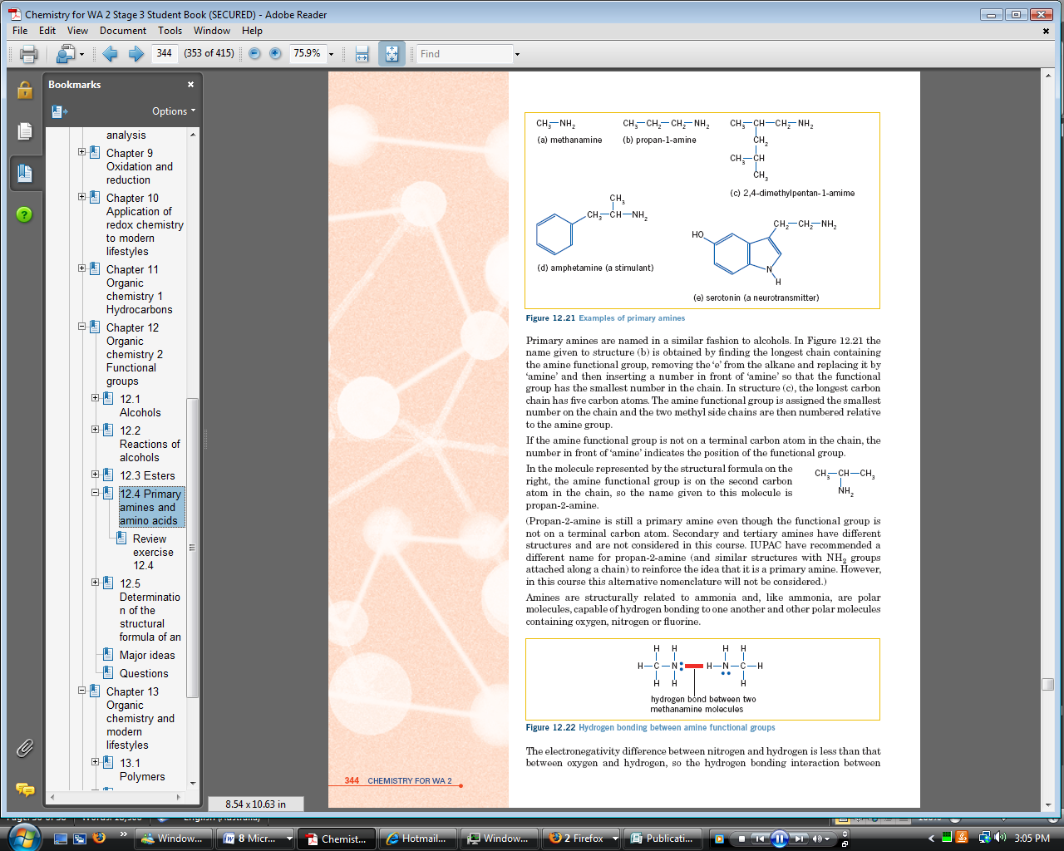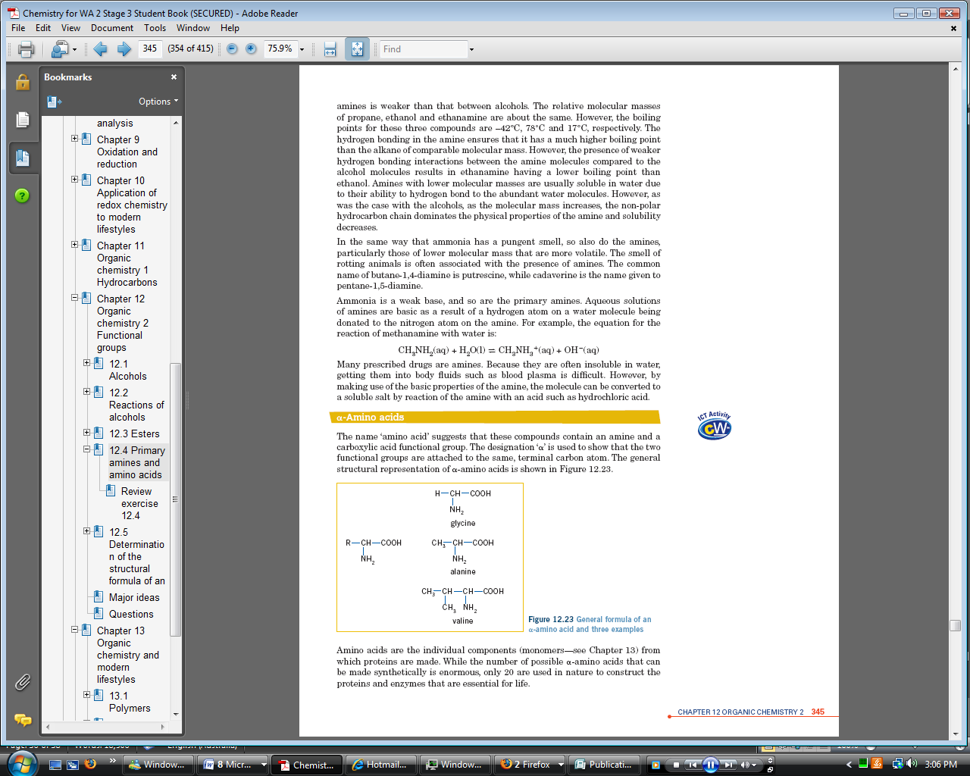

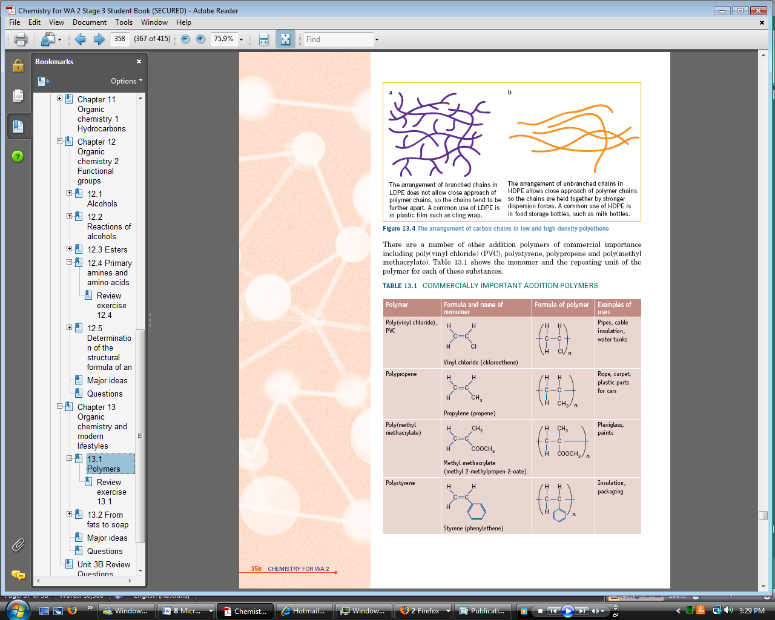**ORGANIC CHEMISTRY IN LIFE**

* Polymers are very large molecules often made up of a backbone or chain in which carbon atoms usually dominate.
* Polymers are formed from the reaction between small molecules known as monomers.
* Alkenes can join together to form polymers in a process called addition polymerisation. Addition polymerisation occurs if the monomer has a carbon-carbon double bond that can be eliminated during polymerisation. The loss of the double bond allows monomer molecules to join end to end
* In this reaction each monomer molecule undergoes an addition reaction with adjacent molecules, in the presence of a catalyst, to form a long chain:

*n*(CH2=CHR) → ~~(~~CH2–CHR ~~)~~*n*

* 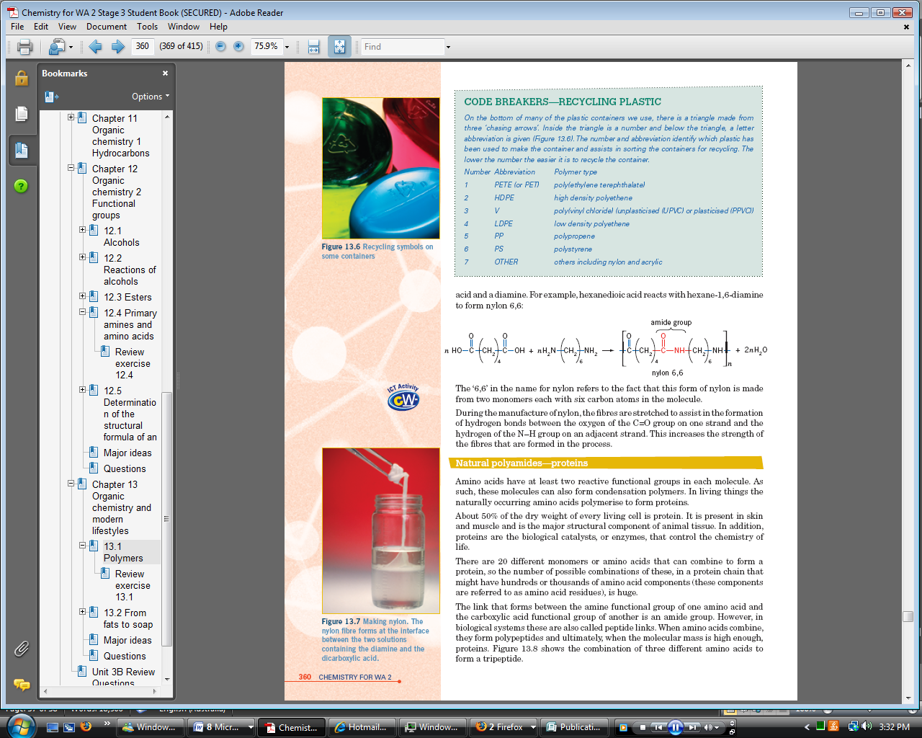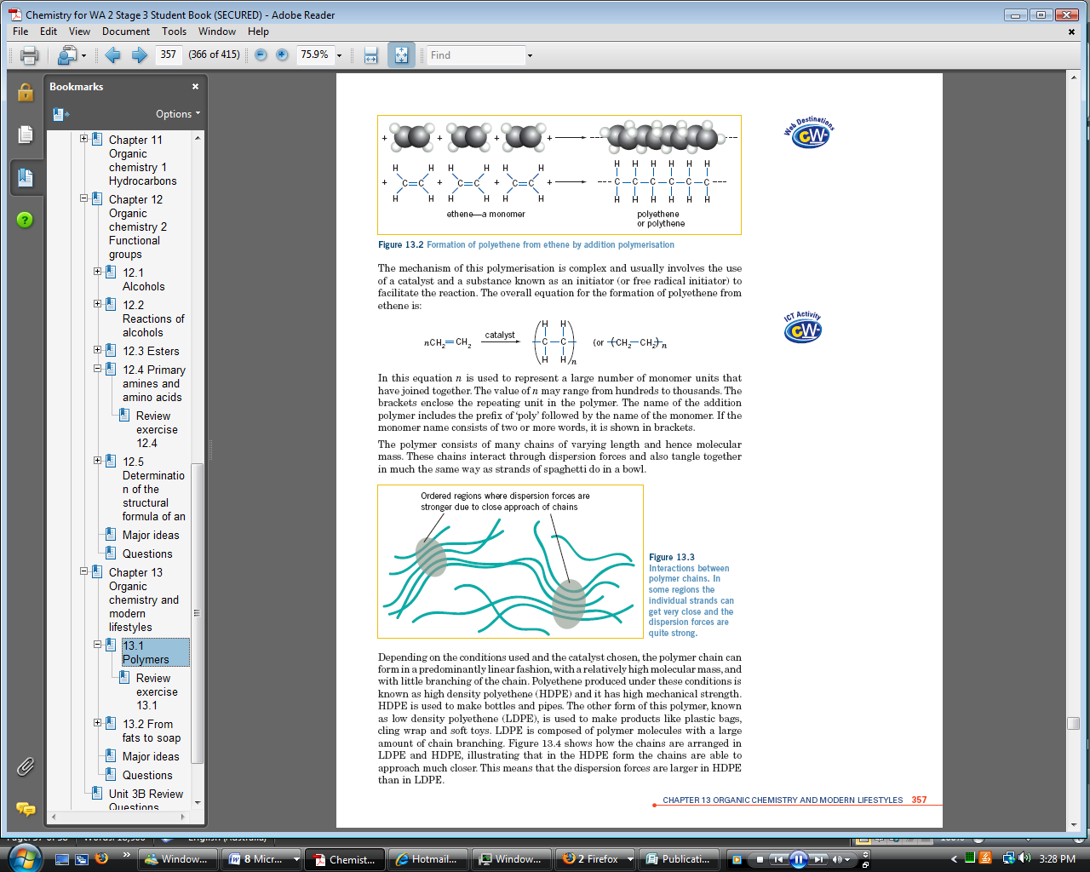The properties of the addition polymers can be changed by increasing the branched side chains on the polymer chain. The more branched side chains present, the weaker the dispersion forces between the molecules.
* Condensation polymers are formed between monomers that each have two reactive functional groups.
* During condensation polymerisation, the polymer is formed together with water.
* A reaction between a dicarboxylic acid and a diol can result in a condensation polymer. The monomers are ‘joined’ by ester groups:

*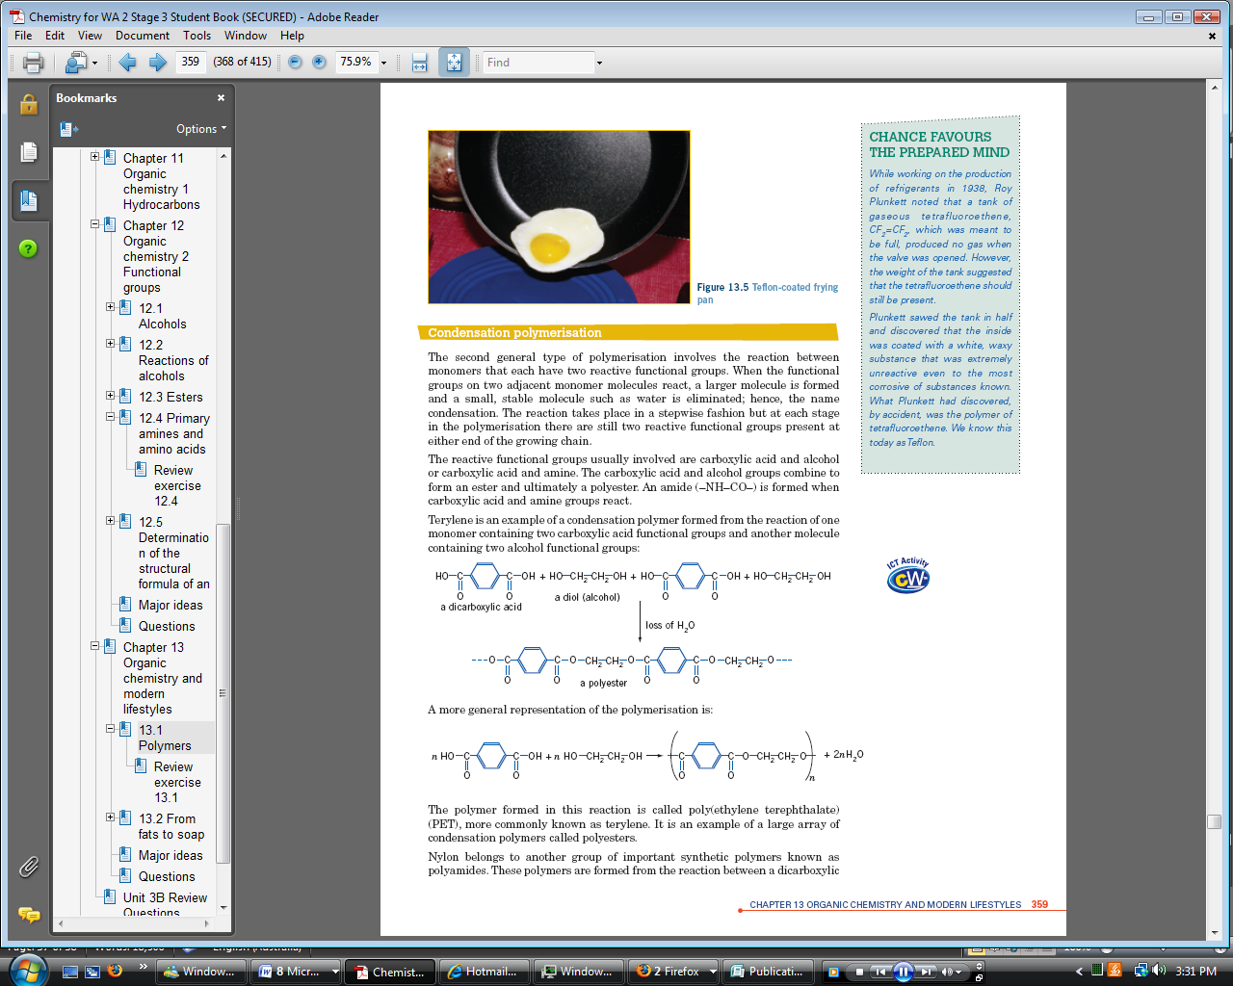n*(HOOC–R–COOH) + *n*(HO–R’–OH) → ~~(~~OC–R–CO–O–R’–O ~~)~~*n* + 2*n*H2O

* A condensation polymer can also form in the reaction of a dicarboxylic acid with a diamine. The monomers are ‘joined’ by amide bonds:

*n*(HOOC–R–COOH) + *n*(H2N–R’–NH2) → ~~(~~ OC–R–CO–HN–R’–NH~~)~~ *n* + 2*n*H2O

* 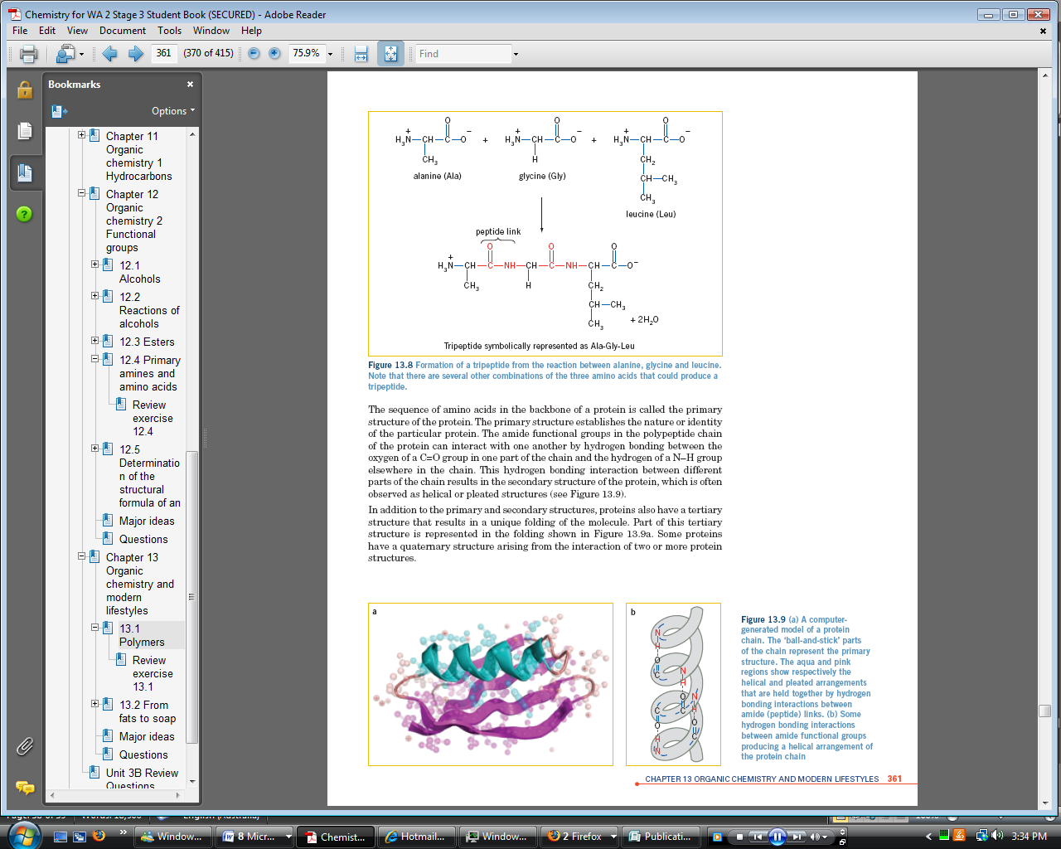Proteins are natural polyamides, formed by the condensation polymerisation of amino acids.
* Each amino acid molecule has two functional groups, a carboxylic acid group and an amine group, that can react with the functional groups on other amino acids.
* The bonds between the amino acids are amide bonds, but they are also called peptide bonds.
* Hydrogen bonding (and ionic bonding) between parts of a protein chain cause it to fold in a particular way to give the secondary structure of the protein.
* 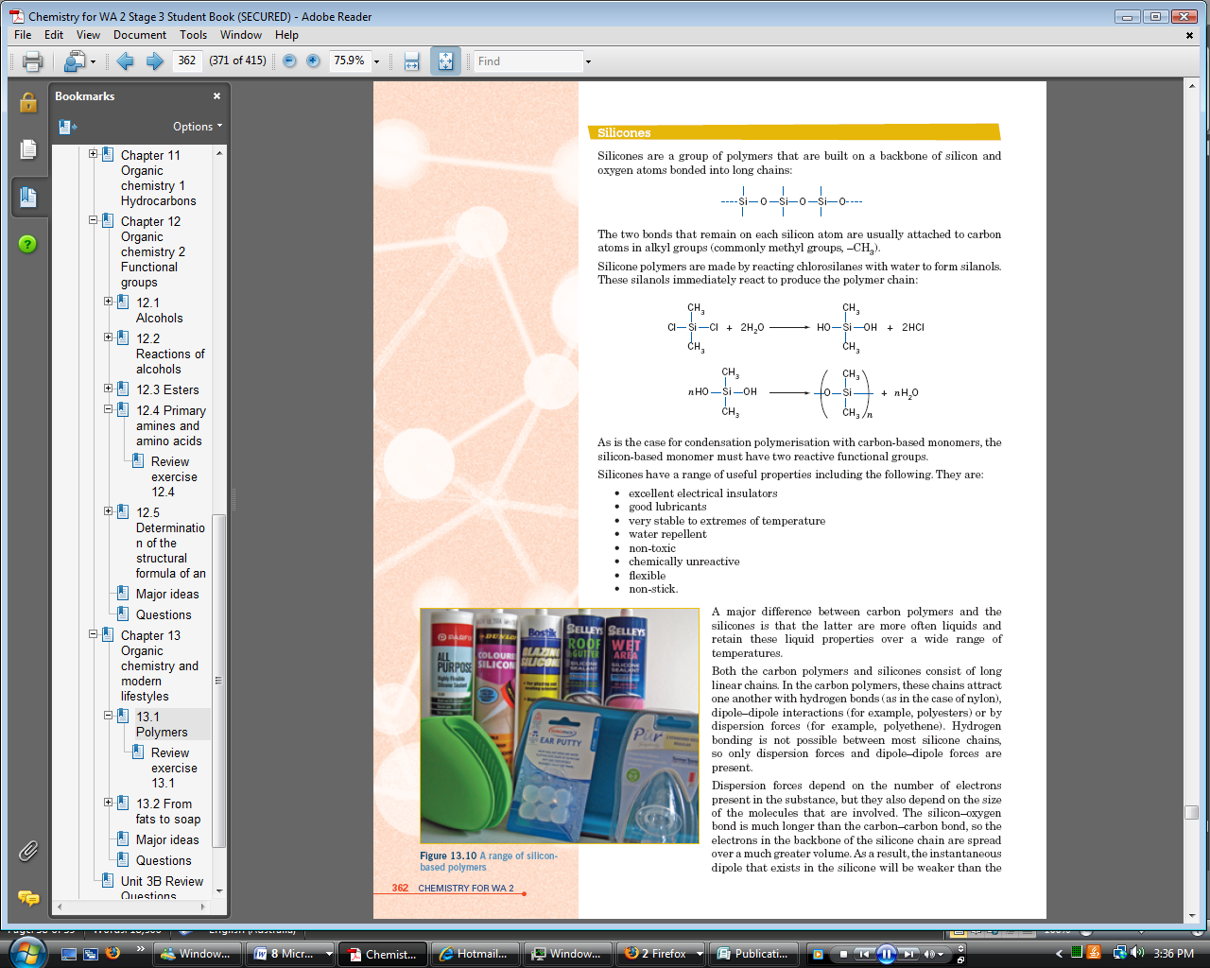Silicones are a group of polymers that are built on a backbone of silicon and oxygen atoms bonded into long chains.
* 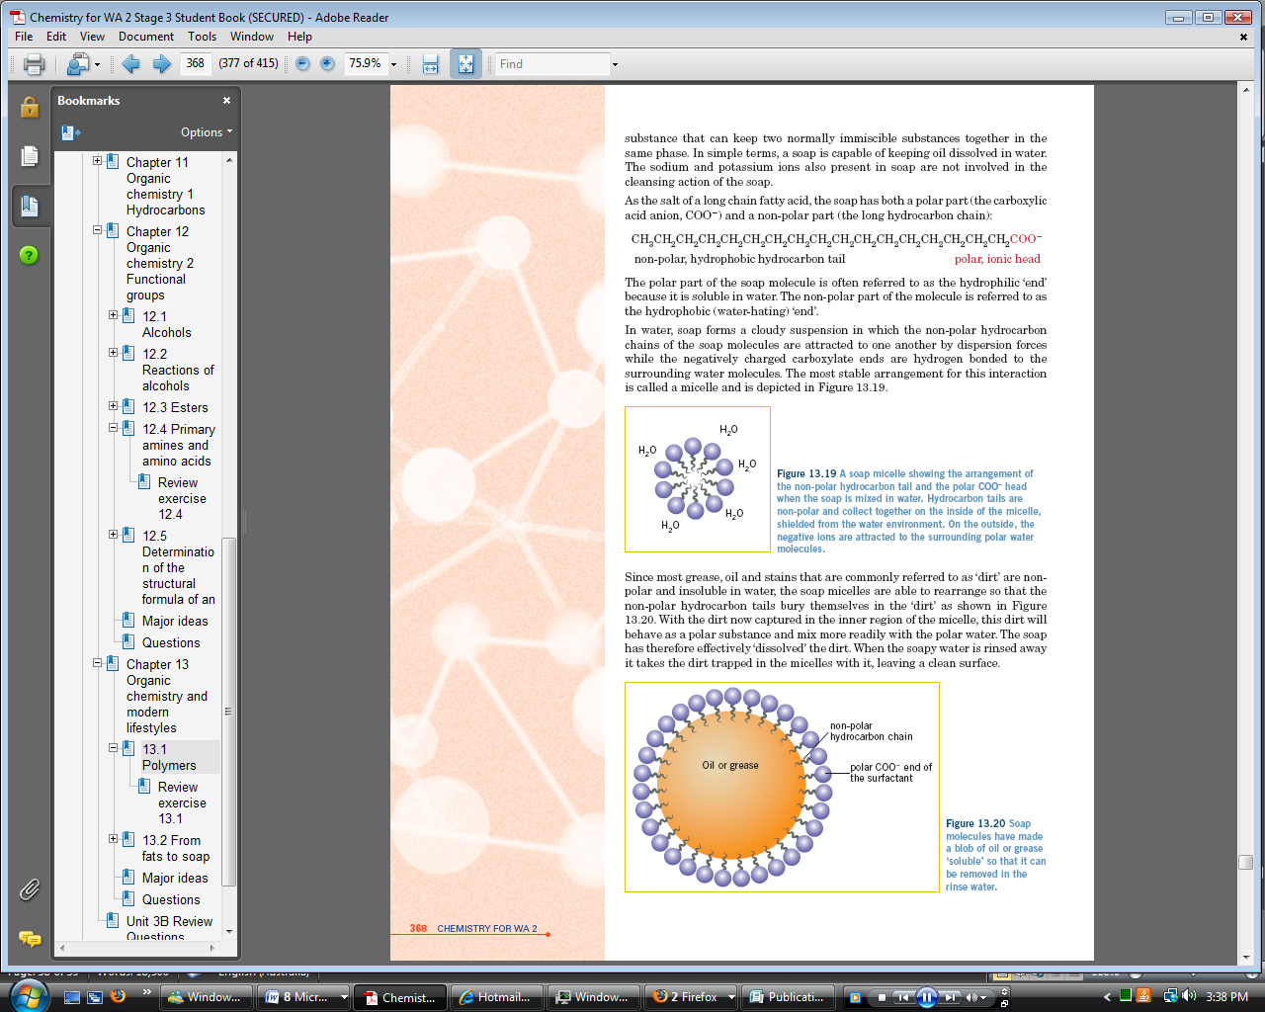Soap is made in a saponification reaction in which an oil or fat is boiled with NaOH or KOH solution:

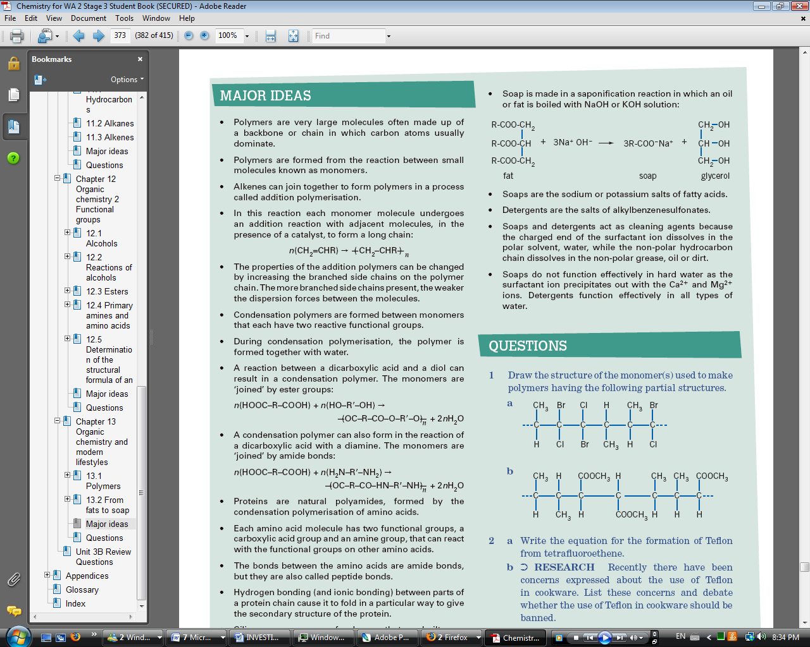

* Soaps are the sodium or potassium salts of fatty acids.
* Detergents are the salts of alkylbenzenesulfonates.
* Soaps and detergents act as cleaning agents because the charged end of the surfactant ion dissolves in the polar solvent, water, while the non-polar hydrocarbon chain dissolves in the non-polar grease, oil or dirt.
* 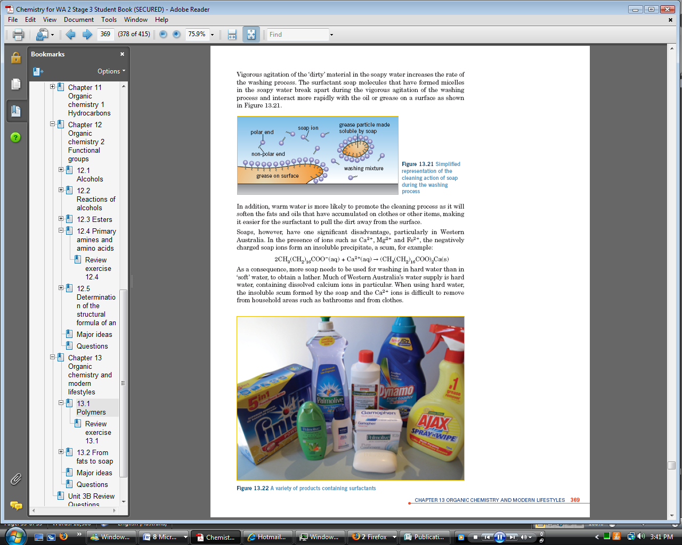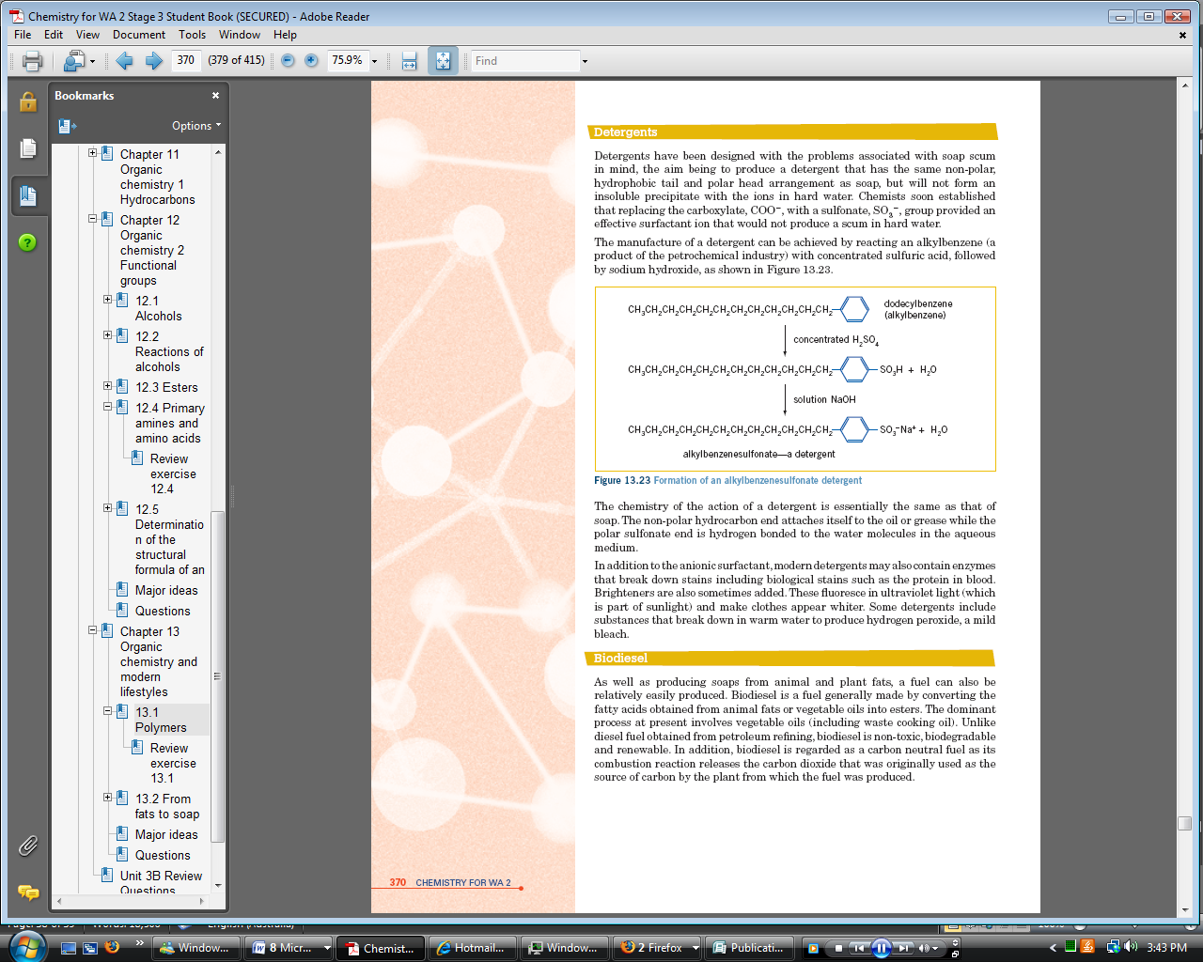Soaps do not function effectively in hard water as the surfactant ion precipitates out with the Ca2+ and Mg2+ ions. Detergents function effectively in all types of water.

**EMPERICAL FORMULA OF ORGANIC COMPOUNDS**

* The empirical formula of a hydrocarbon gives the simplest whole number ratio of carbon to hydrogen atoms in the molecule.
* Empirical formulas can be determined from percentage composition by mass, mass composition, or from informa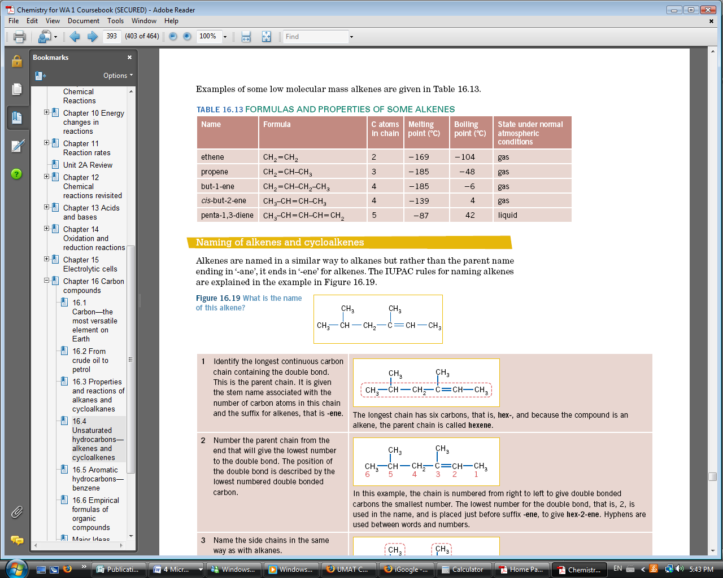tion about the amounts of carbon dioxide and/or water produced in combustion.
* From combustion we find the mass of H2O and CO2 at this point we convert both to moles and find the moles of C and H after which u find he mass of C and H. you then take these two masses away from the sample mass and this gives u the mass of O or N in the compound.

Basic format of empirical formula calculation in hydrocarbons

|  |  |  |  |  |
| --- | --- | --- | --- | --- |
|  |  | Carbon(C) | Hydrogen (H) | Oxygen (O)/ Nitrogen(N) |
| 1 | Mass |  |  |  |
| 2 | Moles |  |  |  |
| 3 | ÷ by smallest (i.e. Ratio) |  |  |  |
| 4 | × if needed otherwise go to step 5 |  |  |  |
| 5 | Round |  |  |  |

.: EF (Empirical Formula) is_______________________

To find the molecular formula of a compound

$$Ratio= \frac{Molecule Formula Mass}{Emperical Formula Mass}$$

Multiply this ratio by the coefficients in the formula to find the molecular formula of the compound

**Significant Figure Rules**

1. All NON-ZERO digits ARE significant
2. Zeros that fall between 2 significant digits ARE significant
3. Zeros to the left of the 1st non-zero digit are NOT significant
4. Zeros at the end of a number and to the right of the decimal point ARE significant
5. Zeros at the end of a number and to the left of the decimal point are NOT significant unless otherwise indicated.
6. If a zero is indicated to be significant and is “against” the rules scientific notation must be used
7. All results must be read and recorded to half the smallest scale division i.e. If a measuring cylinder goes up by 1mL then a measurement can be taken to the nearest 0.5mL
8. For a calculation that uses multiplication or division, the answer is given with as many significant figures as the measurement with the least number of significant figures
9. If calculations involve adding or subtracting, the answer is quoted with as many decimal places as with the least number of decimal places. When counting decimal places, the measurements must be expressed with the same powers of ten
10. Answers must be less accurate i.e. less significant figures than there are in the question